

Cricket FIS Report

IMAT 3406: Fuzzy Logic & Knowledge Based Systems

[25]

DE MONTFORT UNIVERSITY

# Abstract

This report covers the use of fuzzy logic within Cricket, which is a domain where fuzzy logic lacks prevalence as opposed to other domains; this does not limit its scope, but it rather adds to the curiosity of what fuzzy logic could be used for. The system created in this report makes use of batting and bowling statistics (each contained within their own sub-FISs) of an eligible cricket player and attempts to output a crisp value which can be used to assess their all-round capabilities. Whilst this system is not perfect, it can be improved further to elevate its accuracy and precision and it does demonstrate how fuzzy logic can be used effectively for Cricket. Though the system is made for the ODI format of Cricket, it is possible to adapt this system to work with other formats within Cricket, in the future.

# Introduction

Fuzzy logic is an alternative approach to logic as it distinguishes itself from binary logic by being able to handle overlaps and values in between intervals, instead of being limited to crisp values like binary logic. Since fuzzy logic has vast potential in other fields, this report investigates whether it could have a suitable application in Cricket. Despite there being limited research about this field, attempts were made to provide an overview of the literature that exists regarding fuzzy logic in sports. Furthermore, this report details the design for the system including results for rigorous testing that was conducted to improve the efficiency, robustness and performance of the system.

In addition, the test data originates from ESPN’s Cricket website which contains various pages of statistics for Cricket players. Utilising test data from ESPN, meant that the system needed to be built for real world data as opposed to just theoretical data which may not be anywhere near as accurate. The system overview section of this report covers the logical choices made for choosing suitable interval ranges for certain input variables.

The MATLAB software package allowed the development of three different FISs required by the system into a single .m file. Microsoft Excel was used extensively for the development of the rulebases, recording of the test data and the evaluation of the test results.

# Literature Review

In simple words fuzzy logic can be considered as a way to deal to vagueness and uncertainty that classical/binary logic would struggle to do so. [4, 12] Whilst binary/classical logic is concerned with absolutes and whether something is true or not, fuzzy logic is interested with degrees of membership/truth hence why fuzzy sets make use of membership functions [3,11]. Fuzzy logic can be considered a special form of probabilistic reasoning as it allows the effective realisation of many realistic conditions such as approximate, vague, uncertain and etc. – these are closer to the actual world and human thinking [3]. In addition, fuzziness deals with beliefs and to what degree these beliefs are specified which enables fuzzy sets to deal with imprecise, inconsistent and inexact information. [9] Fuzzy logic techniques allow the mapping of classes to objects to binary logic (false as 0 and true as 1) as well as intermediate values between 0 and 1 [3].

Fuzzy logic has been effectively modelled in multiple fields, some of which include data mining, expert systems, prediction, forecasting, decision making and robotics [3,6,7]. Despite fuzzy logic clearly having success in multitude of different disciplines, it has not been applied in the field of sports very (especially Cricket) considering that it has great potential [3]. Fuzzy logic is more than capable of being applied intuitively in sports, since its foundations have become increasingly firm ever since its inception by Lofti

A. Zadeh in 1965 and its influence within the mathematical community and parts of the science

community has developed substance and discernibility [4]. Initially, Zadeh introduced the concept of fuzzy models by combining standard mathematical models paired with linguistic descriptions from the natural language used within expert systems [8].

Fuzzy logic can be modelled using a fuzzy inference systems (FIS) which can allow a crisp value(s) to be inputted to the system and fuzzified so that it can be changed into a fuzzy input(s) [11]. The inputs can be passed through a rule-base where they can be assigned a particular output depending on their values. Using defuzzification a crisp value may be retrieved from the FIS which can then provide a degree of membership that can be interpreted to make certain conclusions [11]. There are various types of FIS, however there are only two distinct ones such as Mamdani and Tagaki-Sugeno (TS); each FIS has its set of strengths of weaknesses [5]. But for this particular project, the Mamdani style FIS would be more appropriate as its more interpretive than a T-S model from a human perspective whilst being more intuitive and showing greater legibility [5,7]. In addition, the Mamdani style FIS is available as a standard tool in the fuzzy logic toolbox within MATLAB [10, 12]; this increases its suitability for rapid testing and prototyping.

Proposing a Mamdani style FIS for a system where cricket players can be scored on their all-rounder ability is a viable yet modern approach, since the field of sport is lacking in suitable applications of fuzzy logic. There have been some applications of fuzzy logic in sports [1] uses this concept to create a performance evaluator to rate cricket players based on how well they perform in matches, whereas [2] uses fuzzy logic to analyse batting techniques to help coaches train their students. In addition, [3] uses fuzzy logic to calculate strength training in sports with emphasis on how it use data collected from weight training machines to form an insightful analysis . All of these papers support the use of fuzzy logic in sports and the way in which it can be used with technology to add a newer dimension to sport [2]. Furthermore, Cricket is among the more popular sports in the world [1] and implementing a FIS about how well-rounded cricket players are would definitely encourage more fuzzy logic to applied in sports especially if it can benefit people such as coaches, members of each playing nation’s cricket board as well the cricket players themselves. As there has been a general absence of fuzzy logic within sports

[3] it would make sense to implement a system to demonstrate its potential and ability to help people, considering that its perfectly compatible in an array of other fields [3,4].

For an all-rounder scoring Mamdani style FIS which judges how well rounded a cricket player is in terms of batting and bowling, it would make sense to make use of two FISs which lead into a main FIS. The batting ability of a cricket player can be modelled into FIS to calculate ‘batting strength’ as an output which would take common batting statistics as inputs. A similar approach can be applied for another FIS to calculate the ‘bowling strength’ as an output, which would take in common bowling statistics as inputs. Definitive research will need to be conducted into the sport of Cricket, so that the correct inputs may be used for the batting and bowling FISs. Once the batting and bowling FISs are implemented, these can be directly fed to a single FIS in order to calculate the all-round strength of a cricket player. The crisp output obtained from the main FIS can be used to determine all-round strength of a cricket player and this information can be considered important for coach of a cricket team as well as members of the team’s cricket board (for international matches). It is imperative to note that there are three distinct formats in Cricket which are Test, One-Day International (ODI) and T20. If this FIS is to be used to compare the strength all-rounders within a team, the data fed through the FIS should be strictly from the same format in order to make accurate comparisons.

# System Overview

## Design Considerations:

Since there are three different formats in Cricket, it would be sensible to choose a single format that will form the basis of this FIS. As the One Day International (ODI) format is the most established format of Cricket in the world at the moment, it would be nice to devise a FIS for it first and then possibly create similar systems for the Test and T20 formats (as desirable extensions) once this FIS is fully operational. The parameters for each input variable will vary depending on the format, e.g. the range for the runs scored input variable may or may not be greater for the Test format, considering that it is the longest format that is played in Cricket. However, since this FIS will make use of the ODI format the parameters for the input variables will be decided appropriately. The best way to approach this consideration would be to find out the highest and lowest values for each variable, this can be found by researching the person with the highest/lowest value (usually in the form of a career record) respective of each input so that an adequate range can be specified for each input variable. There are a lot of websites which have records for every cricket player in the world, however ESPN’s website <http://www.espncricinfo.com/> will be used as the only source where test data for the FISs can be collected from. This will ensure that there is a level of consistency with regards to the data used within the FISs. Information regarding types of batting and bowling career statistics is handily available on [13].

## Fuzzy Inference sub-Systems:

### Batting FIS:

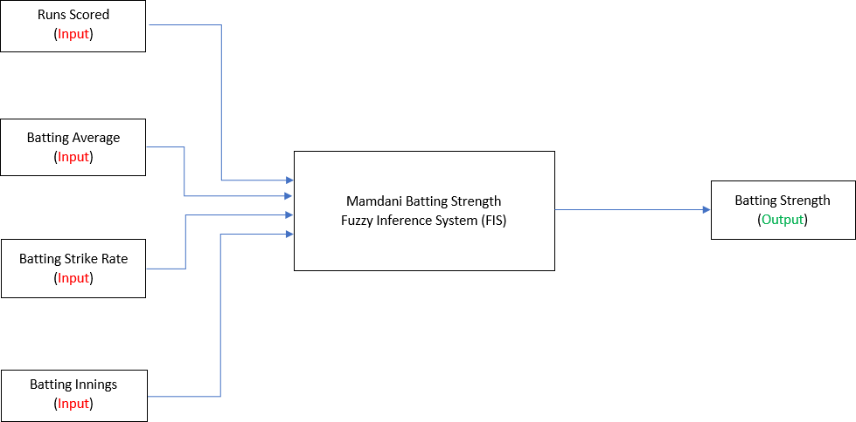

**Figure 1:** Diagram of the Batting FIS.

#### Description of the Batting FIS:

The batting FIS will have four inputs which will be used to calculate the batting strength of a cricket player, the inputs chosen for this FIS are career statistics best suited to calculating the batting performance of a cricket player.

|  |  |  |  |
| --- | --- | --- | --- |
| **Variable** | **Type of Variable** | **Range** | **Intervals** |
| Runs Scored | Input | 0 - 20000 | Very, Low, Medium, High, Very High |
| Batting Average | Input | 0 - 80 | Low, Medium, High |
| Batting Strike Rate | Input | 0 - 600 | Low, Medium, High |
| Batting Innings | Input | 20 - 500 | Low, Moderate, High |
| Batting Strength (%) | Output | 0 - 100% | Very, Low, Medium, High, Very High |

**Figure 2:** Breakdown of input and output variables with their stated ranges and intervals for the Batting FIS.

#### Justification of the parameters chosen:

For the ‘runs scored’ input variable, the range chosen is from 0 – 20000 as this provides a fair range for cricket players at either end of the spectrum, i.e. it allows newer players to be compared with more experienced players (who have accumulated a lot of runs in their career). As the ODI record for the leading run scorer lies with Sachin Tendulkar who has scored 18,426 runs [14], it would make sense to have the range end at 20,000 runs as it is possible for records to be broken.

The ‘batting average’ input variable is calculated by dividing the total number of runs that a player has scored from the number of times that they have been given out. The range chosen for this input variable is 0 - 80 - the maximum parameter has been set to 80 in order to factor in the ODI record for the highest batting average, which is 67 by Ryan ten Doeschate [15].

The ‘batting strike rate’ input variable is calculated by dividing the total number of runs scored by a player from the number of balls that they have faced and then multiplying the value by 100. Theoretically, this variable can extend all the way to 600, assuming that a player never gets out and hits each ball they face for 6 runs. As this may sound rather idealistic and implausible the individual intervals for this variable will factor in a realistic starting region for the ‘High’ fuzzy set, ensuring that it starts from a reasonable value that is reflective of real-world statistics.

The ‘batting innings’ input variable is measure of how many innings a cricket player has batted in, the maximum parameter for the range chosen is 500 - this reflects the ODI record for the most innings batted in, which is 452 by Sachin Tendulkar [16]. The minimum parameter chosen is 20 by default, due to the fact that the batting averages and strike rates are not calculated for players who have not played at least 20 innings [17]. The purpose of this input variable is to ensure that the FIS is fair to players who are newer to the games, and not actively discriminated against more experienced players who have accumulated a lot of runs in their career.

### Bowling FIS:

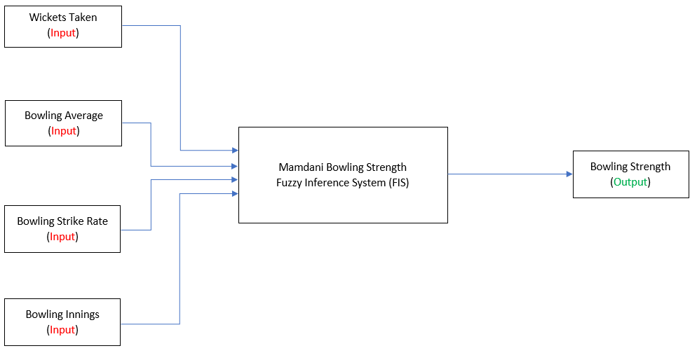

**Figure 3:** Diagram of the Bowling FIS.

#### Description of the Bowling FIS:

The bowling FIS will have four inputs which will be used to calculate the bowling strength of a cricket player, the inputs chosen for this FIS are career statistics best suited to calculating the bowling performance of a cricket player.

|  |  |  |  |
| --- | --- | --- | --- |
| **Variable** | **Type of Variable** | **Range** | **Intervals** |
| Wickets Taken | Input | 0 - 600 | Very, Low, Medium, High, Very High |
| Bowling Average | Input | 140 - 10 | High, Medium, Low |
| Bowling Strike Rate | Input | 130 - 20 | High, Medium, Low |
| Bowling Innings | Input | 0 - 400 | Low, Moderate, High |
| Bowling Strength (%) | Output | 0 - 100% | Very, Low, Medium, High, Very High |

**Figure 4:** Breakdown of input and output variables with their stated ranges and intervals for the Bowling FIS.

#### Justification of the parameters chosen:

For the ‘wickets taken’ input variable, the parameters chosen is 0 – 600, this allow newer players to be compared against more experienced players by providing fairness to players at either end of the spectrum. Since the ODI record for leading wicket taker lies with Muttiah Muralitharan who has taken a total of 534 wickets in his ODI career [18], it would sense to have the parameter end at 600 wickets, so that it factors in cricket players who may break this record.

The ‘bowling average’ input variable is calculated by dividing the runs that a bowler has conceded from the number of wickets they took. A lower bowling average is preferred since it means that a bowler takes fewer runs to dismiss an opposing batsman. The range chosen is 140 - 10, both parameters for this range reflect the highest and lowest ODI bowling averages recorded - this is 103.63 [19] and 14.47

1. respectively.

The ‘bowling strike rate’ input variable is calculated by dividing the number of balls balled by a player from the number of wickets they took and then multiplying the value by 100. A lower strike rate is preferred, since it means that a bowler has to bowl less deliveries in order to dismiss an opposing batman. Theoretically, this variable could end up with a value of infinity assuming that a bowler does not manage to take any wickets, fortunately bowling strike rates are not calculated for bowlers that have 0 wickets. The range chosen for this input variable is 130 - 20, this reflects the highest and lowest strike rates ever recorded for the ODI format which is 124.4 [21] and 22.2 [22] respectively.

The ‘bowling innings’ input variable is a measure of how many innings a cricket player has bowled in; the range chosen is 0 - 400. The maximum parameter chosen reflects the ODI record for the most innings bowled in, which is 372 by Shahid Afridi [23]. The purpose of this input variable is to ensure that the FIS is fair to cricket players that have only recently started playing ODI matches, making sure that they are not disadvantaged against more experienced players who have accumulated more wickets.

## All-rounder Fuzzy Inference System:

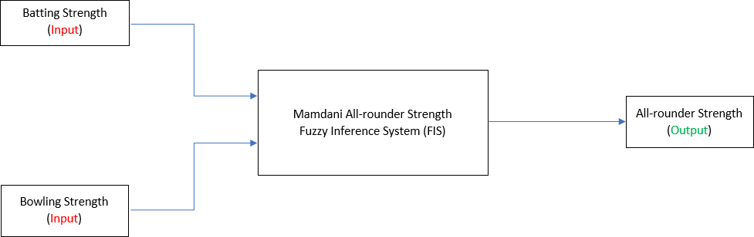

**Figure 5:** Diagram of the All-rounder FIS.

#### Description of the All-rounder FIS:

This FIS takes uses the outputs of the Batting FIS and the Bowling FIS as inputs in order to calculate the All-rounder Strength. By its own virtue this is a fairly logical and simple FIS as it does not add to the overall complexity of the system, meaning that the rule base for this FIS will be fairly simple and intuitive.

|  |  |  |  |
| --- | --- | --- | --- |
| **Variable** | **Type of Variable** | **Range** | **Intervals** |
| Batting Strength (%) | Input | 0 - 100% | Very, Low, Medium, High, Very High |
| Bowling Strength (%) | Input | 0 - 100% | Very, Low, Medium, High, Very High |
| All-rounder Strength (%) | Output | 0 - 100% | Very, Low, Medium, High, Very High |

**Figure 6:** Breakdown of input and output variables with their stated ranges and intervals for the All- rounder FIS.

#### Justification of the parameters chosen:

As this FIS inherits its input variables via the output variable from batting and bowling FISs, the range and the intervals have been unaltered. The All-rounder Strength output variable follows the pattern by having the same range and intervals, so that it can be just as easily as interpreted as the Batting Strength and Bowling Strength variables.

# Experimental Design, Testing and Evaluation

## Initial System Design in MATLAB:

The initial variable declarations, rule bases and fuzzy sets for the Batting, Bowling and all-rounder FISs are covered in the Appendix, on pages 1 - 9. The choice of the membership functions used for each variable was quite straightforward. Trapezoidal membership functions (trapmf) were used as the leftmost and rightmost sets due to them having a plateau region which corresponds to 100% membership association – this allows a more gradual distribution in comparison to other membership functions. Triangle membership functions (trimf) were used for all of the mid-intervals for each input and output variable; the mid-intervals was the region where most of the most overlaps would occur (on either side) and trimf is quite effective at displaying that.

### General notes:

The ranges chosen for the bowling average and the bowling strike rate variable spans negative numbers as opposed to positive numbers, due to the leftmost fuzzy set representing a high bowling average/strike rate which is considered bad. Therefore, the range incorporates negative values in order to successfully display the fuzzy sets correctly, since a receding number range would not work with a trapmf for the rightmost interval, as the fourth value of a trapmf must be greater than or equal to the third value. This should not affect the output of the bowling FIS; to make sure that it does not affect the outputs, there will be dummy test conducted before a set of real-world values are used.

The total number of rules across the entire system is 295; this is a fairly large number, however the rules used in the rule base are supposed to cater for every type of input. As both the batting FIS and the bowling FIS each have 4 input variables with the runs scored/wickets taken variables having 5 intervals

, it is not a surprise to see 135 rules apiece for both FISs. The all-rounder FIS only has 25 rules, which is a relatively low number of rules which factor in every eventuality like the batting and bowling FISs. Despite there being a credible reason for using these 295 rules, it would be sensible to still find a way to optimise the rule base if possible. Hopefully, the testing should help to form a better insight into the rule base and it may be possible to reduce the size of the rule bases.

### Changes to the system:

During the testing stage for the Cricket FISs, some changes were made to the distribution of the fuzzy sets outputted after running the .m file. This mainly covered the fuzzy sets for the output variables Batting Strength, Bowling Strength and All-rounder Strength. As evidenced on pages 8-9 in the Appendix, the mid intervals for each output variable was initially distributed using a trimf. This was slightly problematic as the peak of the trimf was truncated which made it look rather odd. The trimf functions for the mid intervals for the output variables was changed to a Gaussian membership function (gaussmf), to allow a more normal distribution for the set (this is evidenced on pages 10-11 in the Appendix).

## Dummy Testing:

Before real world data was used for the testing of the system, a set of 10 dummy test cases were used to test the system in order to make sure that the .m file was successfully able to read test data from an Excel spreadsheet for both the batting and bowling FISs and successfully output the results to another Excel spreadsheet. The outputs from this Excel spreadsheet would be subsequently be passed to the all- rounder FIS where its results can be outputted to the same spreadsheet. This basic test confirmed that using a negative range of values for the bowling average and strike rate did not affect the output of the bowling FIS in a detrimental way.

## Real world testing:

### Test 1:

Once the initial testing was successful, the system was ready to use real world data directly from the ODI statistics of cricket players via ESPN’s website. A set of 30 random cricket players were chosen to be used as the testing data for the system, in order to make the testing as less biased as possible and to be able to incorporate a wide distribution of data. In addition, the cricket players chosen were a mix of batsmen, bowlers and all-rounders; this was due to the fact that it would be biased to test the system for only one type of cricket player instead of any type cricket player. Furthermore, the reasoning for chosen 30 tests is to ensure that 10 tests can be allocated apiece for each type of cricket player (batsmen, bowler, and all-rounder) can be taken into consideration. The test data chosen for each type of cricket player will be at the boundaries, the middle and random values; using a distributed region of data will allow the system to be tested at extreme cases as well as generic, random cases.

It is to be noted that the system can only work with career statistics for players that have bowling and batting records, as the system cannot input data for players with missing values. Therefore, it may be a good idea to not incorporate test data from players which operate as wicket keeper batsmen, purely because players who take up that role are less likely to have official bowling records for the ODI format. These are caveats because the career statistics are taken from ESPN, which does not calculate certain statistics if they do not meet their minimum requirements.

**The real-world test data used to test the system is provided on page 12 in the Appendix.**

#### Caveats for the test data:

* + Batting Average: players must have batted in at least 20 innings.
  + Batting Strike Rate: players must have faced at least 1000 bowls.
  + Bowling Average: players must have bowled at least 1000 bowls.
  + Bowling Strike Rate: players must have bowled at least 1000 bowls.

### Results of Test 1:

#### Defuzzification:

There were five defuzzification methods that were used to calculate crisp outputs for the batting, bowling and all-rounder FISs. The results for these methods can be found in the Appendix, on pages 14-

15. The comparison table between expected outcomes and actual outcomes is located on pages 16-17, in the Appendix.

#### Analysis:

Most of the actual outcomes for the tests were incorrect and different from the expected outcomes (see table on page 13 in the Appendix), however the defuzzification method with the closest set of values was LOM. It is noticeable that many of the incorrect test outcomes were for the batting FIS as it had a total of 18/30 incorrect outcomes, there were 13/30 incorrect outcomes for the bowling FIS and 11/30 incorrect outcomes for the all-rounder FIS. Furthermore, it is possible that having the runs scored batting FIS variable and the wickets taken bowling FIS set to 5 intervals is causing the system to give incorrect outcomes, since all the other input variables for both FISs are set to 3 intervals.

Therefore, in the second test the number of rules for the batting and bowling FISs rule bases will be reduced from 135 down to 81, in order to see whether this would allow slightly more accurate outcomes for the system as it would not need to deal with too many rules. The rule base for the batting and bowling FISs may also need to be properly checked to see whether some rules may need changing, even they were not invoked during the testing. However, this will occur after second test is completed as it

would not make sense to reduce the rules and tweak the rule base since this could give a completely different set of outcomes in comparison to test 1. In addition, the table of expected outcomes will also need to be modified as the number of intervals for two variables is less than before and the rules associated with those removed intervals is also removed.

## Test 2:

For this test, there will be some major changes to the system in order to have a better chance at improving the actual outcomes. Reducing the number of rules in the batting FIS rule base and the bowling FIS rule base by removing the ‘Very High’ and ‘Very Low’ intervals for the runs scored and wickets taken input variables could potentially improve the actual outcomes. In addition, having less rules in the rule base, enables the system to work faster and more efficiently.

### Changes:

The evidence for changes made to the intervals for the fuzzy set distributions and rule bases are located on pages 18-21, in the Appendix.

### Modified Expected Outcomes:

The table of expected outcomes required modification as the intervals for two input variables were reduced from 5 to 3, meaning that some of the expected outcomes would no longer be correct. The modified table can be found in the Appendix, on page 22.

### Results of Test 2:

#### Defuzzification:

The same five defuzzification methods were also compared for this test, in order to see what differences, it would have in comparison the set of values obtained in the first test. The results for these methods can be found in the Appendix, on pages 23-24. The comparison table between expected outcomes and actual outcomes is located on pages 25-26, in the Appendix.

#### Analysis:

As the expected outcomes for this test were slightly different to the ones for the first test, the crisp values obtained from all the defuzzification methods were different. The best defuzzification methods were centroid, bisector and LOM; all of these methods had a smaller number of incorrect test cases in comparison to the other methods. However, the number of incorrect test cases was still relatively high despite the fact that the expected outcomes were different to the ones used in the first test as well as the rule bases for the batting and bowling FISs being smaller. Therefore, the only way to ensure a higher number of correct test cases is tweak the rules in the rule bases to ensure that the system generates more correct outcomes that closer to the expected outcomes.

## Test 3:

In this test the rule bases for the batting FIS and the bowling FIS were modified to reflect the expected outcomes a lot better, in order to ensure that the actual outcomes can match the expected outcomes more closely. The same table of expected outcomes from the second test was used in this test too, in order to maintain consistency. In addition, the defuzzification results for the SOM and MOM methods were exclude from defuzzification value tables, as these methods performed poorly on the previous tests and it is unlikely that they would outperform the centroid, bisector and LOM methods.

### Modifying the rule bases:

The rule bases for the batting and bowling FISs were modified to better reflect the expected outcomes, evidence for this is available on pages 33-34 in the Appendix.

### Results of Test 3:

#### Defuzzification:

Only the centroid, bisector and LOM defuzzification methods were used to calculate the crisp outputs, as the other two methods performed poorly in the previous tests. The results for these methods can be found in the Appendix, on page 27. The comparison table between expected outcomes and actual outcomes is located on page 28 in the Appendix.

#### Analysis:

The results for this test was very positive since the three defuzzification methods that had the best results from the previous tests showed a much better improvement. The defuzzification method with the best values was bisector which only had a single test case which failed, in comparison to centroid and LOM which had a few, but multiple test cases that still returned some incorrect outcomes.

### Final changes:

The gaussmf distribution for the ‘Low’ interval of the Batting Strength, Bowling Strength and All-rounder Strength variables were tweaked to allow a more normal distribution, this was done by changing the centre from 22.5 to 27.5. In addition, test case 24 gave the incorrect Batting Strength for the bisector, because the ‘Medium’ and ‘High’ intervals for the runs scored input variable did not overlap. This was fixed to allow a suitable overlap which would allow test case 24 to give the correct output, by changing the right footprint of the trimf for the ‘Medium’ interval from 8000 to 9000. These changes did affect the defuzzification results for the bisector method (see page 29 in the Appendix), however the differences for the values are minor as the values still lie within the interval range specified by the expect outcomes. The changes made to the gaussmf distribution for the ‘Low’ interval of the Batting Strength, Bowling Strength and All-Rounder Strength variables can be found on pages 30-32 of the Appendix. The new parameters of the ‘Medium’ interval for the runs scored input variable is included in the Appendix, on page 30.

## Final System Configuration:

This can be found within the Appendix, on pages 30-36 and this includes the latest set of variable declarations, fuzzy sets and rule bases for each FIS.

# Critical Reflection

The system proved to be able match the intervals specified in the expected outcomes quite well, when bisector was chosen as the defuzzification method. Fixing errors due to incorrect actual outcomes was quite difficult to do for this system, since this required the rule bases to be reduced (as a result of the first test) and then modified (as a result of the second test). However, after the third test the system started to perform a lot better, even the less accurate defuzzification methods for this system (centroid and LOM) returned a lot less incorrect outcomes in comparison to the first and second test. Thus, the testing proved to benefit the system a great deal as it is a lot more robust and effective at correctly outputting values that lie within the interval ranges specified by the expected outcomes.

At first it was almost impossible to think that this system could be optimised in any way, since it was necessary to have combination between the inputs for the batting and bowling FISs. However, as the

results of the first test showed it was still possible to reduce the number of rules in the rule bases by allowing the intervals for runs scored and wickets taken input variables to be reduced from 5 to 3. Although this did not improve the results that were obtained in the second test, reducing the rule bases did allow the system to operate much faster than before. In addition, the reduction of intervals reduced the complexity of the rule bases; it is also easier to compare input variables that have the same number of intervals. However, it is possible that this could have reduced the accuracy of the system. Therefore, it is possible to have a version of this system which has more intervals for each of the input variables, if the object of interest is to increase accuracy at the cost of increasing complexity.

Furthermore, All-rounder Strength crisp values that landed within the ‘Medium’ fuzzy set have three different levels of interpretations. A ‘Medium’ output could indicate a batsmen with good batting statistics and poor bowling statistics, a bowler with poor batting statistics and good bowling statistics or an all-rounder with average batting and bowling statistics. Having three different interpretations for the ‘Medium’ interval could cause some confusion, however it is positive that the actual outcomes finally managed to match the expected outcomes well. The system does give outputs that reflect the test data that was chosen, as the career statistics for the chosen batsmen to tend to have a lower Bowling Strength, the opposite is also true for the bowlers chosen as they tend to have a lower Batting Strength. A similar pattern also exists for the all-rounders chosen, as weaker all-rounders will have more mediocre batting and bowling strengths, as opposed to stronger all-rounders.

All in all, this system has the potential to perform reasonably well in a real-world environment where it can be used by coaches belonging to a Cricket team to assess a player’s all-round performance. The only significant limitation being that it is unable to accept career statistics from players which have not met the minimum requirements (mentioned in test 1). This system could be developed into a mobile-friendly application which could take inputs in the form of career statistics and use the power of the FISs to calculate the all-rounder strength. Though this system may require more extensive testing to deem it suitable for use in a real-world scenario, the foundation for this has hopefully already been laid. Furthermore, this system also has the potential to be adapted to the Test, T20 and even the new and upcoming T10 format [24].

# Conclusion

To conclude, this project was a wonderful learning experience for me as I was privileged to learn about fuzzy logic and the merits that it has over classical logic. I feel that the system I developed is more than capable of being applied in a real-world scenario, it may not be perfect, but it is quite robust due to the level of testing I conducted. The only reservation I have regarding the system development is not using the fuzzy logic toolbox to quickly prototype the system and to create the rules. Since I was dealing with the creation three FISs as opposed to just a single one, I was more inclined to start writing the code directly in MATLAB by using the model multiple FIS template that was kindly offered to us. It is quite possible that each FIS could have been prototyped using the fuzzy logic toolbox and then converted directly to an .m file – this may have improved the efficiency of the development by saving time. Moreover, I could have added support for more career statistics if I had more time to develop the system, however this could still be possible as a future extension for this system.

Nevertheless, being able to develop this system in a field of application where I possess great interest towards was deeply satisfying and invigorating. I was not only able to learn more about the technicalities behind how career statistics are calculated in Cricket, but I was also able to bring my own value to the system which is something I am rather pleased with. This project proves that there is a great potential for fuzzy logic in sports, especially Cricket.

# Bibliography

1. Singh, G., Bhatia, N. and Singh, S. (2011). Fuzzy Logic Based Cricket Player Performance Evaluator. IJCA Special Issue on “ Artificial Intelligence Techniques - Novel Approaches & Practical Applications, [online] pp.11-16. Available at: [http://citeseerx.ist.psu.edu/viewdoc/download?rep=rep1&type=pdf&doi=10.1.1.206.3426](http://citeseerx.ist.psu.edu/viewdoc/download?rep=rep1&amp;type=pdf&amp;doi=10.1.1.206.3426) [Accessed 15 Nov. 2018].
2. Curtis, M. (2009). Analyzing cricket batting technique. SPIE Newsroom, [online] p.1. Available at: https://ieeexplore.ieee.org/stamp/stamp.jsp?tp=&arnumber=5201206 [Accessed 14 Nov. 2018].
3. Novatchkov, H. and Baca, A. (2013). Fuzzy Logic in Sports: A Review and an Illustrative Case Study in the Field of Strength Training. International Journal of Computer Applications, [online] 71(6), pp.8-14. Available at: https://research.ijcaonline.org/volume71/number6/pxc3888675.pdf [Accessed 16 Nov. 2018].
4. Zadeh, L. (1996). Fuzzy logic = computing with words. IEEE Transactions on Fuzzy Systems, [online] 4(2), pp.103-111. Available at: https://ieeexplore.ieee.org/stamp/stamp.jsp?tp=&arnumber=493904 [Accessed 14 Nov. 2018].
5. Chai, Y., Jia, L. and Zhang, Z. (2009). Mamdani Model based Adaptive Neural Fuzzy Inference System and its Application in Traffic Level of Service Evaluation. In: *2009 Sixth International Conference on Fuzzy Systems and Knowledge Discovery*. [online] Beijing: IEEE, pp.555-567. Available at: https://ieeexplore.ieee.org/stamp/stamp.jsp?tp=&arnumber=5359238 [Accessed 16 Nov. 2018].
6. Perera, L., Carvalho, J. and Guedes Soares, C. (2014). Solutions to the Failures and Limitations of Mamdani Fuzzy Inference in Ship Navigation. *IEEE Transactions on Vehicular Technology*, [online] 63(4), pp.1539-1554. Available at: https://ieeexplore.ieee.org/stamp/stamp.jsp?tp=&arnumber=6654345 [Accessed 17 Nov. 2018].
7. Tung, W. and Quek, C. (2009). A Mamdani-Takagi-Sugeno based Linguistic Neural-Fuzzy Inference System for Improved Interpretability-Accuracy Representation. In: *2009 IEEE International Conference on Fuzzy Systems*. [online] IEEE, p.367. Available at: https://ieeexplore.ieee.org/stamp/stamp.jsp?tp=&arnumber=5277194 [Accessed 16 Nov. 2018].
8. Yager, R. and Filev, D. (1993). On the Reasoning in Fuzzy Logic Control and Fuzzy Expert Systems. In: *[Proceedings 1993] Second IEEE International Conference on Fuzzy Systems*. [online] IEEE, pp.839-844. Available at: https://ieeexplore.ieee.org/stamp/stamp.jsp?tp=&arnumber=327551 [Accessed 17 Nov. 2018].
9. Venkats Subba Reddy, P. (2013). Some Methods of Fuzzy Conditional Inference and Fuzzy Reasoning. In: *2013 International Conference on Fuzzy Theory and Its Applications (iFUZZY)*. [online] IEEE, pp.1-4. Available at: https://ieeexplore.ieee.org/stamp/stamp.jsp?tp=&arnumber=6825410 [Accessed 16 Nov. 2018].
10. Bova, S., Codara, P., Maccari, D. and Marra, V. (2010). A Logical Analysis of Mamdani-type Fuzzy Inference, I Theoretical Bases. In: *International Conference on Fuzzy Systems*. [online] IEEE, pp.1-8. Available at: https://ieeexplore.ieee.org/stamp/stamp.jsp?tp=&arnumber=5584830 [Accessed 15 Nov. 2018].
11. Ardiansyah, A., Samo, R. and Giandi, O. (2018). Rain Detection System for Estimate Weather Level Using Mamdani Fuzzy Inference System. In: *2018 International Conference on Information and Communications Technology (ICOIACT)*. [online] IEEE, pp.1-3, 5. Available at: https://ieeexplore.ieee.org/stamp/stamp.jsp?tp=&arnumber=8350711 [Accessed 17 Nov. 2018].
12. Uk.mathworks.com. (2018). *What Is Fuzzy Logic?- MATLAB & Simulink- MathWorks United Kingdom*. [online] Available at: https://uk.mathworks.com/help/fuzzy/what-is-fuzzy-logic.html [Accessed 17 Nov. 2018].
13. Morgan, D. (2018). *DM's Explanation of Cricket - Statistics*. [online] Dangermouse.net. Available at:<http://dangermouse.net/cricket/statistics.html>[Accessed 23 Nov. 2018].
14. Cricinfo. (n.d.). *Records | One-Day Internationals | Batting records | Most runs in career | ESPNcricinfo*. [online] Available at: <http://stats.espncricinfo.com/ci/content/records/83548.html> [Accessed 22 Nov. 2018].
15. Cricinfo. (n.d.). *Records | One-Day Internationals | Batting records | Highest career batting average | ESPNcricinfo*. [online] Available at:<http://stats.espncricinfo.com/wi/content/records/282911.html>[Accessed 19 Nov. 2018].
16. Cricinfo. (n.d.). *Sachin Tendulkar*. [online] Available at:<http://www.espncricinfo.com/india/content/player/35320.html>[Accessed 22 Nov. 2018].
17. En.wikipedia.org. (n.d.). *Batting average (cricket)*. [online] Available at: https://en.wikipedia.org/wiki/Batting_average_(cricket) [Accessed 22 Nov. 2018].
18. Cricinfo. (n.d.). *Records | One-Day Internationals | Bowling records | Most wickets in career | ESPNcricinfo*. [online] Available at: <http://stats.espncricinfo.com/ci/content/records/283193.html> [Accessed 23 Nov. 2018].
19. Cricinfo. (n.d.). *Records | One-Day Internationals | Bowling records | Worst career bowling average | ESPNcricinfo*. [online] Available at:<http://stats.espncricinfo.com/wi/content/records/283880.html>[Accessed 24 Nov. 2018].
20. Cricinfo. (n.d.). *Records | One-Day Internationals | Bowling records | Best career bowling average*

*| ESPNcricinfo*. [online] Available at:<http://stats.espncricinfo.com/wi/content/records/283257.html>[Accessed 24 Nov. 2018].

1. Cricinfo. (n.d.). *Records | One-Day Internationals | Bowling records | Worst career strike rate | ESPNcricinfo*. [online] Available at: <http://stats.espncricinfo.com/ci/content/records/283858.html> [Accessed 21 Nov. 2018].
2. Cricinfo. (n.d.). *Records | One-Day Internationals | Bowling records | Best career strike rate | ESPNcricinfo*. [online] Available at: <http://stats.espncricinfo.com/wi/content/records/283275.html> [Accessed 23 Nov. 2018].
3. Cricinfo. (n.d.). *Shahid Afridi*. [online] Available at:<http://www.espncricinfo.com/pakistan/content/player/42639.html>[Accessed 22 Nov. 2018].
4. League, T. (n.d.). *T10 League 2018 Scores, Fixtures, Tables & News - ESPNcricinfo*. [online] ESPNcricinfo. Available at: <http://www.espncricinfo.com/series/_/id/18522/season/2018/t10-> league [Accessed 15 Dec. 2018].
5. pngtree (2018). *Vector cricket bat Free Vector and PNG*. [image] Available at: https://pngtree.com/freepng/vector-cricket-bat_3561798.html [Accessed 13 Dec. 2018].

Appendix

# Pre-testing system design in MATLAB:

### Variable declarations:

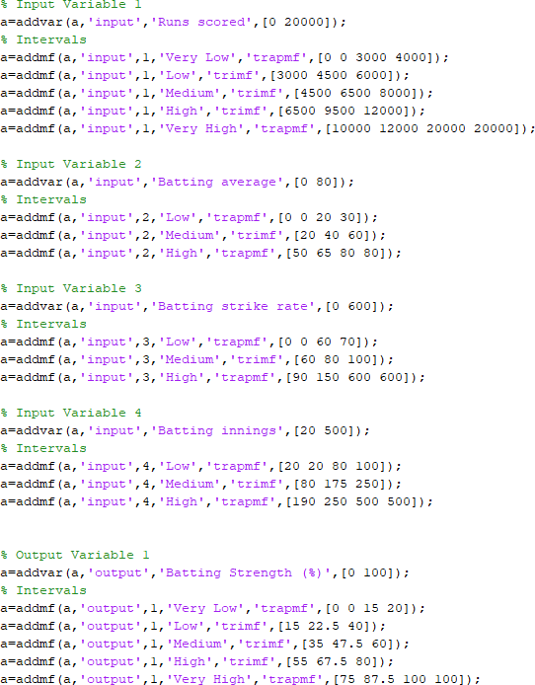

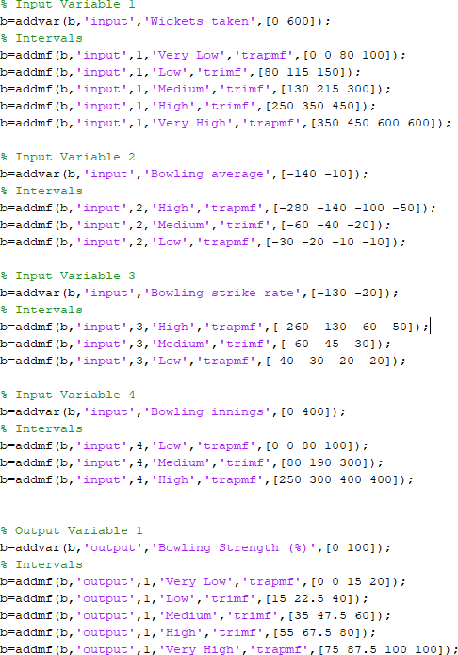

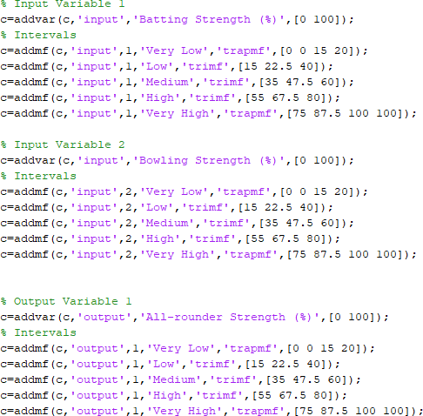

Rule bases:

#### Batting FIS:

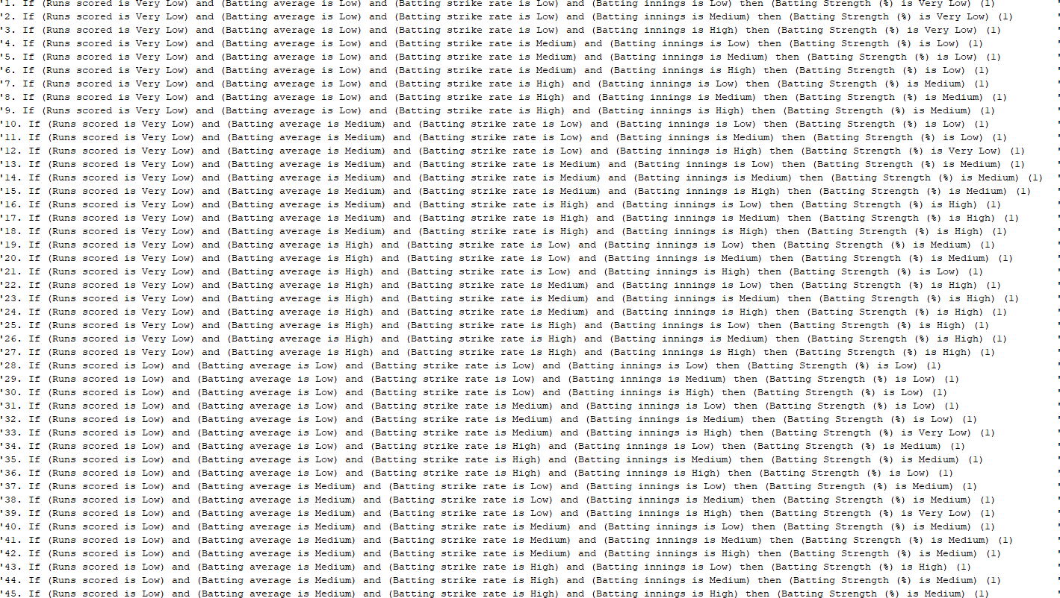

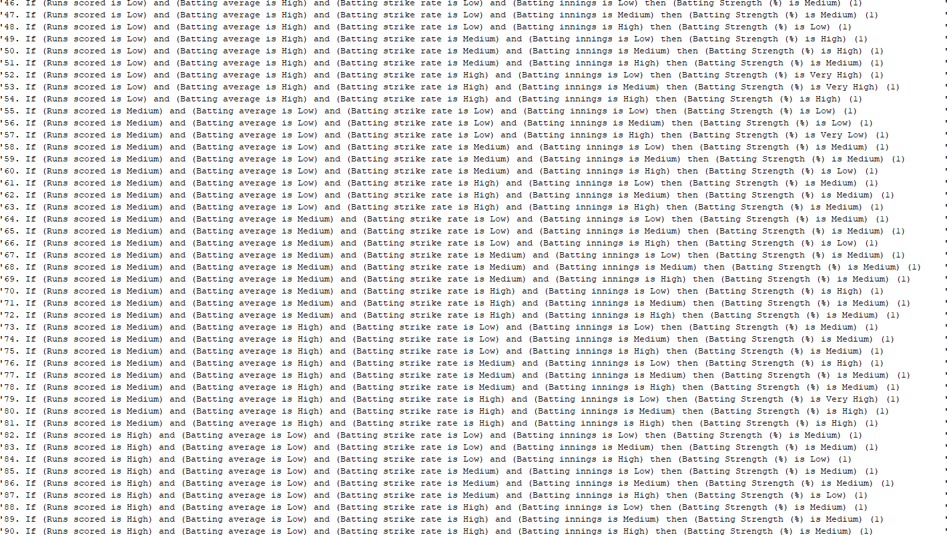

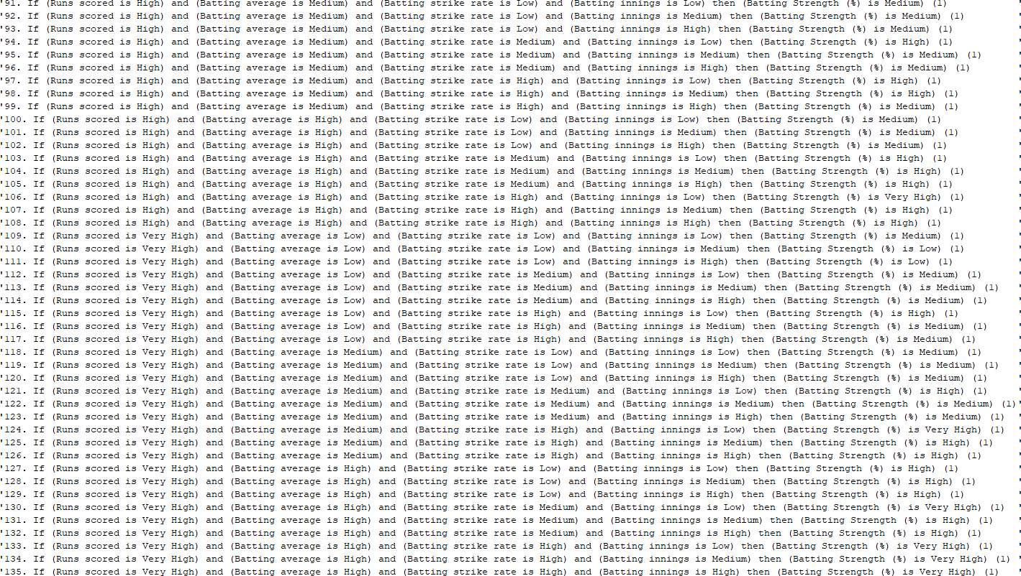

Bowling FIS:

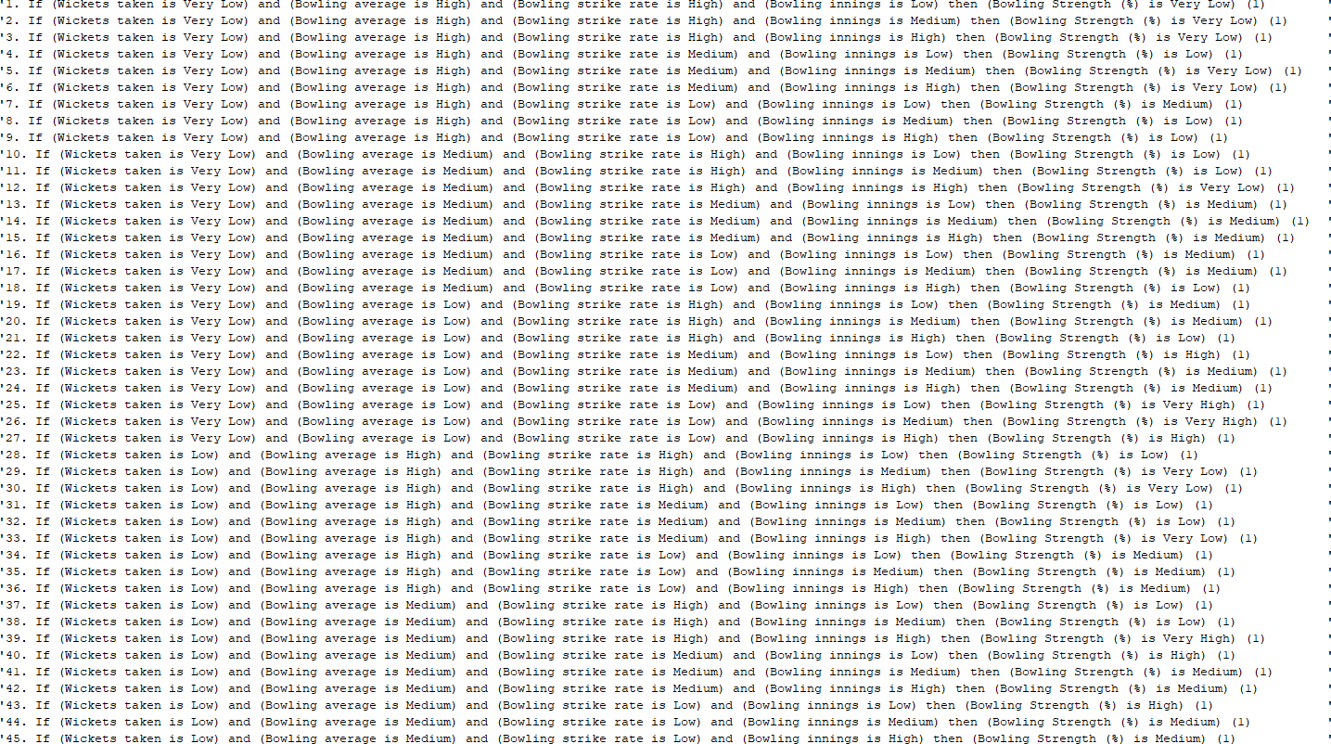

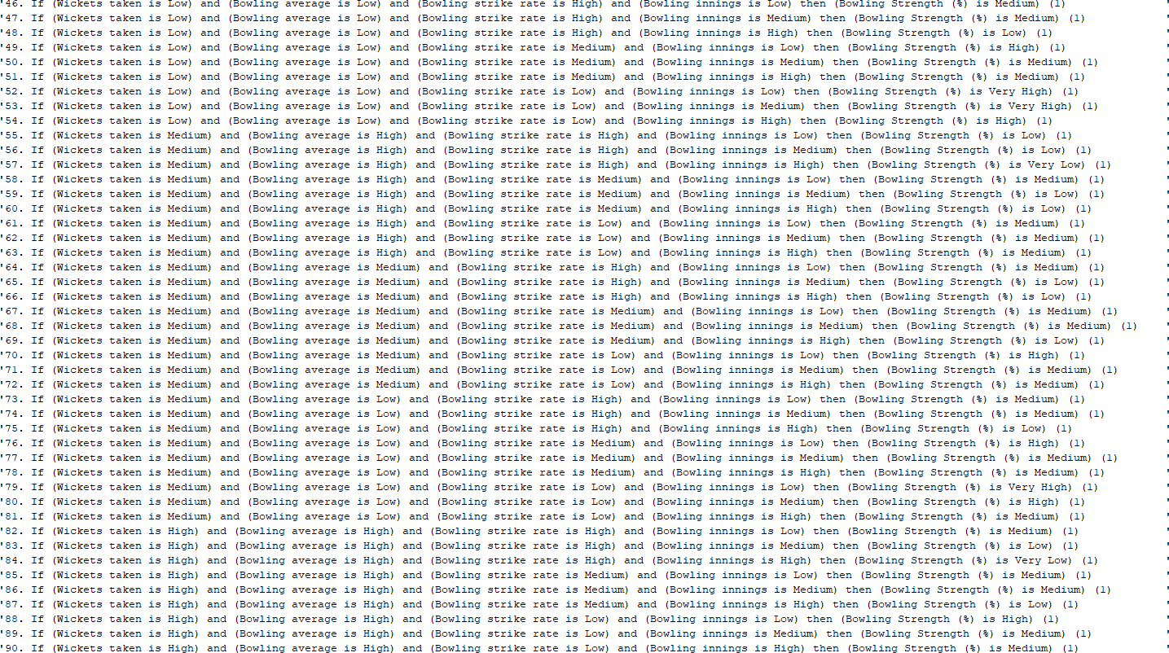

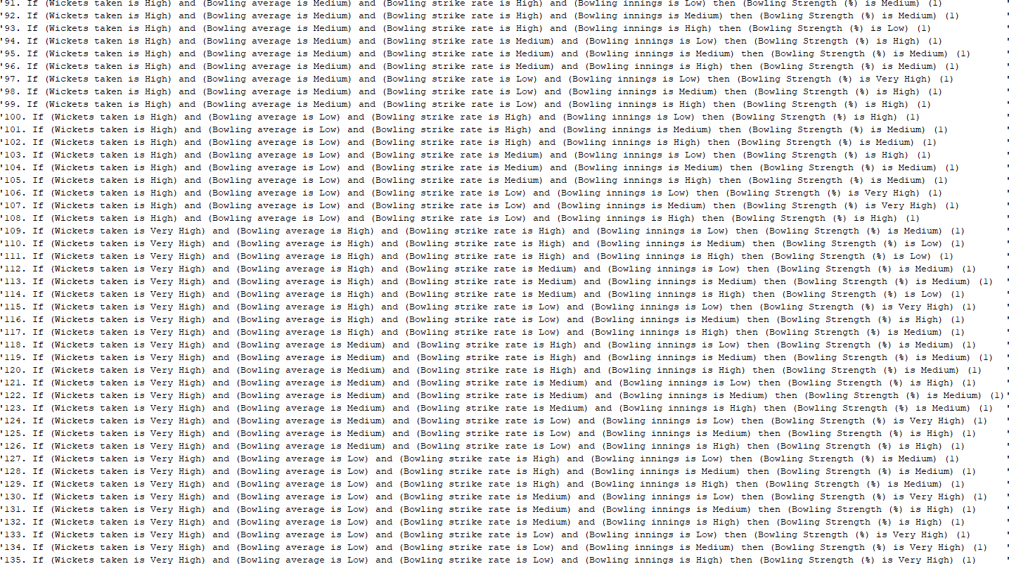

All-rounder FIS:

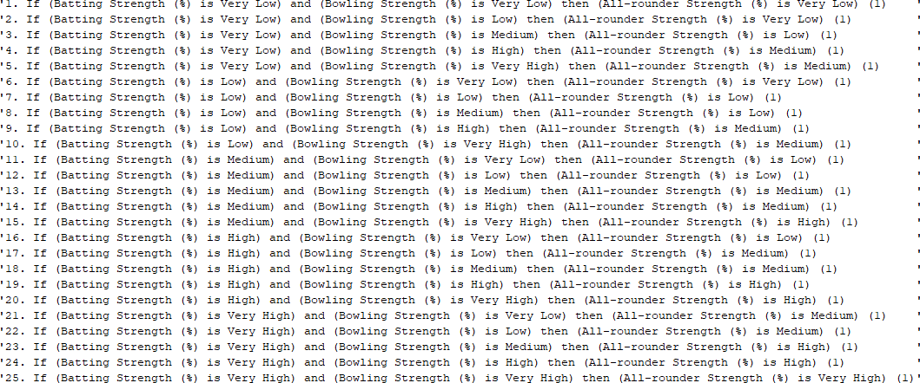

Fuzzy Set Distribution:

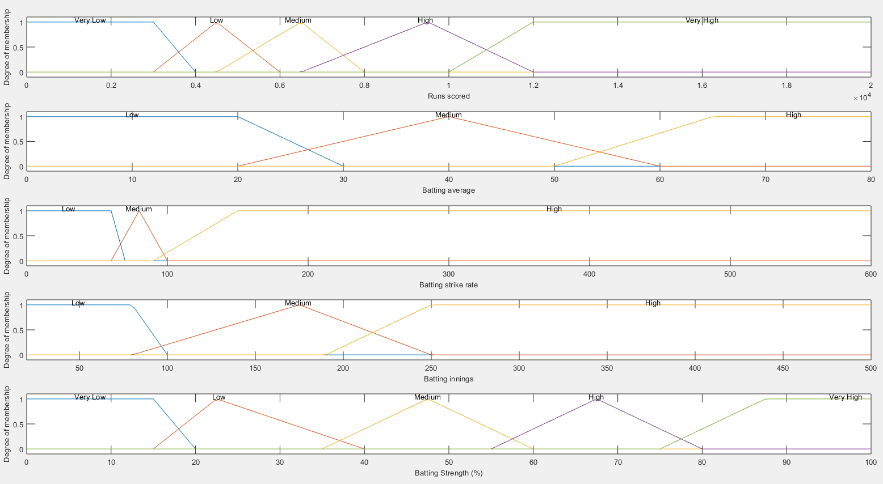

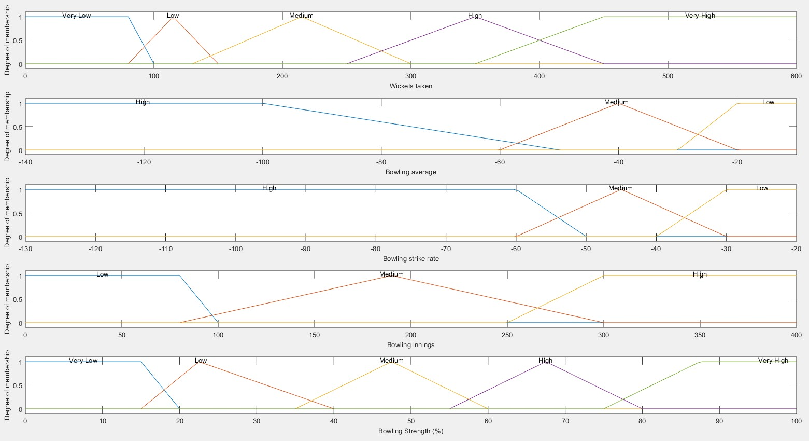

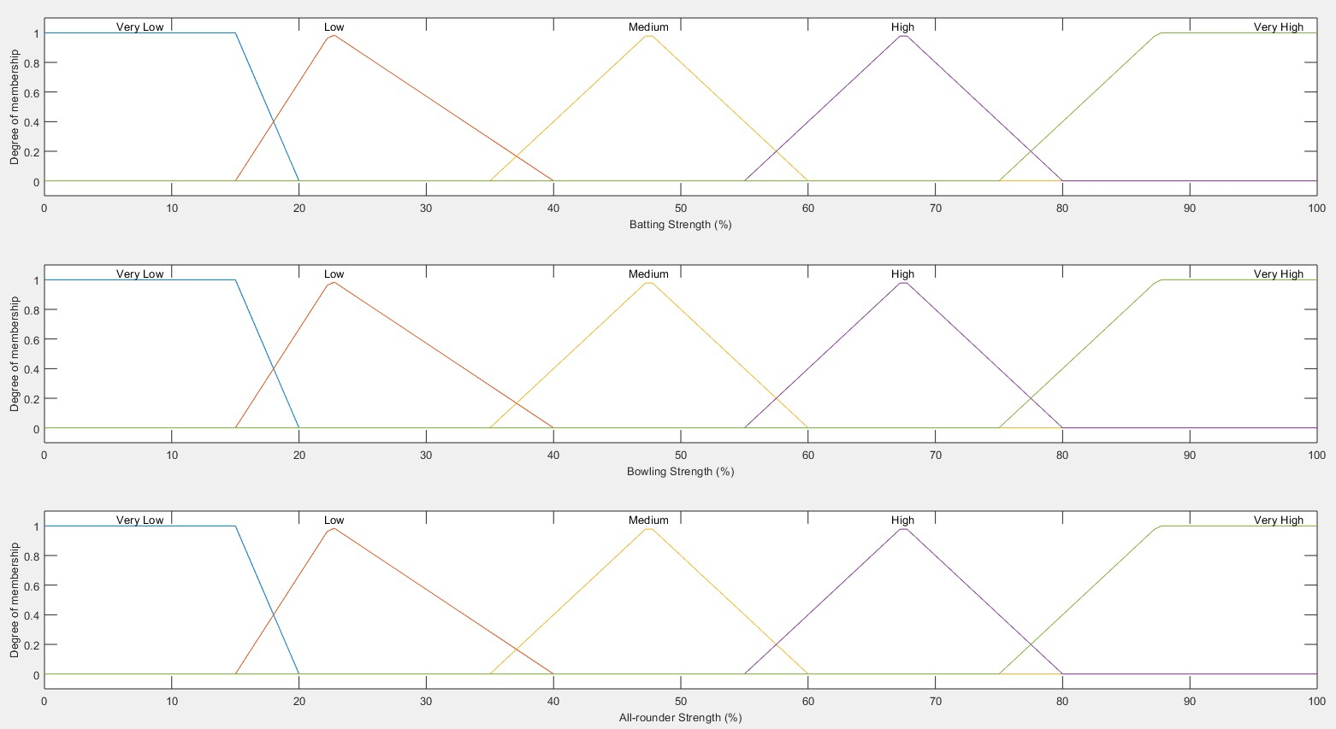

Changes to the distribution: (trimf to gaussmf to the mid intervals for the batting, bowling and all-rounder strength fuzzy sets)

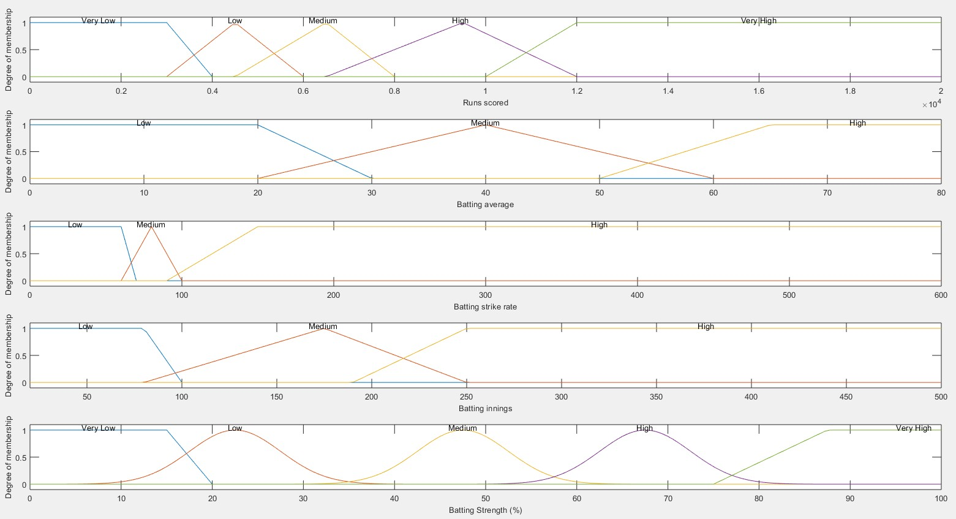

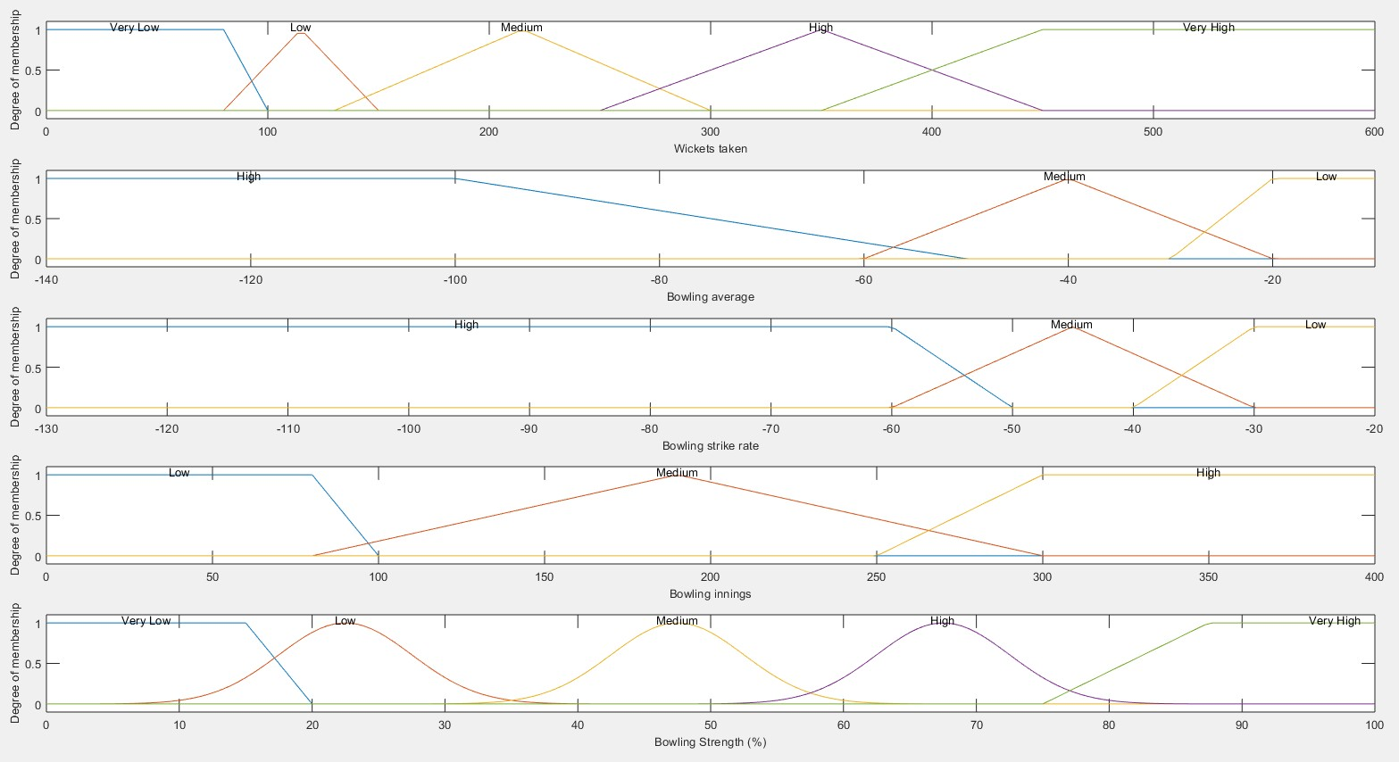

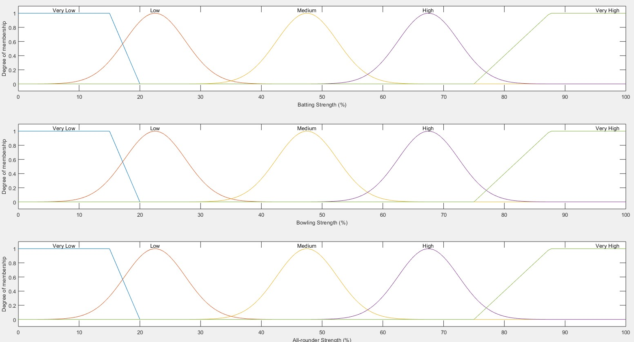

Test 1:

Real World Test Data:

|  |  |  |  |  |  |  |  |  |
| --- | --- | --- | --- | --- | --- | --- | --- | --- |
| **Test No.** | **RS** | **BaA** | **BaSR** | **BaI** | **WT** | **BoA** | **BoSR** | **BoI** |
| **1** | 18426 | BA | 86.23 | 452 | 154 | -44.48 | -52.2 | 270 |
| **2** | 13704 | 42.03 | 80.39 | 365 | 3 | -34.66 | -50 | 5 |
| **3** | 1447 | 51.67 | 79.72 | 40 | 3 | -37 | -36.3 | 8 |
| **4** | 884 | 42.09 | 107.93 | 31 | 22 | -29.59 | -36.5 | 26 |
| **5** | 1541 | 67 | 87.7 | 32 | 55 | -24.12 | -28.7 | 33 |
| **6** | 3431 | 41.84 | 86.35 | 94 | 27 | -34.48 | -38.7 | 36 |
| **7** | 8824 | 39.21 | 80.67 | 244 | 6 | -31.83 | -40.3 | 13 |
| **8** | 998 | 28.51 | 130.45 | 44 | 65 | -32.73 | -33.4 | 51 |
| **9** | 590 | 26.81 | 117.06 | 25 | 1 | -129 | -100 | 4 |
| **10** | 10889 | 39.16 | 71.24 | 318 | 4 | -42.5 | -46.5 | 8 |
| **11** | 674 | 6.8 | 77.56 | 162 | 534 | -23.08 | -35.2 | 341 |
| **12** | 3717 | 16.52 | 88.33 | 280 | 502 | -23.52 | -36.2 | 351 |
| **13** | 2025 | 13.68 | 72.42 | 220 | 400 | -27.53 | -39.4 | 320 |
| **14** | 623 | 11.75 | 71.77 | 63 | 45 | -50.24 | -72.2 | 69 |
| **15** | 676 | 21.8 | 101.19 | 38 | 118 | -14.47 | -22.2 | 50 |
| **16** | 280 | 12.72 | 89.45 | 38 | 145 | -21.44 | -25.9 | 75 |
| **17** | 371 | 19.52 | 53.69 | 29 | 32 | -48.65 | -64.8 | 40 |
| **18** | 424 | 20.19 | 90.4 | 27 | 15 | -58.33 | -76 | 29 |
| **19** | 1751 | 21.61 | 75.5 | 98 | 158 | -22.29 | -50.8 | 112 |
| **20** | 1176 | 17.81 | 83.58 | 110 | 380 | -23.36 | -29.4 | 217 |
| **21** | 13430 | 32.36 | 91.2 | 433 | 323 | -36.75 | -46 | 368 |
| **22** | 707 | 20.2 | 86.21 | 39 | 15 | -58.93 | -69.2 | 37 |
| **23** | 3519 | 26.45 | 86.86 | 205 | 393 | -24.5 | -39.9 | 297 |
| **24** | 8064 | 23.57 | 117 | 369 | 395 | -34.51 | -44.7 | 372 |
| **25** | 8701 | 36.55 | 87.67 | 278 | 111 | -38.68 | -45.4 | 161 |
| **26** | 1039 | 27.34 | 90.74 | 56 | 113 | -30.64 | -33.3 | 77 |
| **27** | 11579 | 44.36 | 72.89 | 314 | 273 | -31.79 | -39.3 | 283 |
| **28** | 2968 | 25.36 | 82.3 | 141 | 199 | -29.51 | -32.7 | 150 |
| **29** | 670 | 29.13 | 114.52 | 27 | 40 | -40.95 | -44.2 | 41 |
| **30** | 5757 | 40.54 | 90.44 | 169 | 168 | -31.79 | -38.4 | 163 |

Key:

**RS** = Runs scored

**BaA** = Batting Average **BaSR** = Batting Strike Rate **BaI** = Batting Innings

**WT** = Wickets taken

**BoA** = Bowling Average **BoSR** = Bowling Strike Rate **BoI** = Bowling Innings

### Expected Outcomes:

|  |  |  |  |
| --- | --- | --- | --- |
| **Test No.** | **Batting Strength** | **Bowling Strength** | **All-rounder Strength** |
| **1** | High | Low | Medium |
| **2** | High | Medium | Medium |
| **3** | High | Medium | Medium |
| **4** | Very High | Medium | High |
| **5** | Very High | Medium | High |
| **6** | Medium | Medium | Low |
| **7** | High | Medium | Medium |
| **8** | Medium | Medium | Low |
| **9** | Medium | Low | Very Low |
| **10** | High | Medium | Medium |
| **11** | Low | Very High | Medium |
| **12** | Low | Very High | Medium |
| **13** | Very Low | Very High | Low |
| **14** | Low | Low | Very Low |
| **15** | Medium | Very High | Medium |
| **16** | Low | High | Medium |
| **17** | Very Low | Medium | Low |
| **18** | Medium | Low | Low |
| **19** | Low | Medium | Low |
| **20** | Low | High | Medium |
| **21** | High | Medium | Medium |
| **22** | Low | Medium | Low |
| **23** | Medium | High | Medium |
| **24** | Medium | High | Medium |
| **25** | High | Medium | Medium |
| **26** | Low | Medium | Low |
| **27** | High | Medium | Medium |
| **28** | Low | High | Medium |
| **29** | Medium | Medium | Medium |
| **30** | High | Medium | Medium |

Defuzzification Values:

*Centroid vs Bisector:*

|  |  |  |  |  |  |  |
| --- | --- | --- | --- | --- | --- | --- |
| **Test No.** | **CENTROID** | | | **BISECTOR** | | |
| **Batting Strength** | **Bowling Strength** | **All-rounder Strength** | **Batting Strength** | **Bowling Strength** | **All- rounder**  **Strength** |
| **1** | 47.5 | 34.83201132 | 34.02334243 | 47 | 34 | 27 |
| **2** | 47.5 | 47.5 | 47.5164241 | 47 | 48 | 48 |
| **3** | 52.48263177 | 47.5 | 47.52047301 | 50 | 47 | 48 |
| **4** | 67.5 | 53.01696706 | 48.31035508 | 67 | 49 | 48 |
| **5** | 67.5 | 78.4006219 | 67.4634986 | 67 | 86 | 67 |
| **6** | 47.5 | 47.5 | 47.5164241 | 47 | 47 | 48 |
| **7** | 47.5 | 47.5 | 47.5164241 | 47 | 47 | 48 |
| **8** | 61.54176712 | 47.5 | 47.52345466 | 64 | 47 | 48 |
| **9** | 57.74616249 | 8.555555556 | 26.03373438 | 58 | 8 | 24 |
| **10** | 47.5 | 47.5 | 47.5164241 | 47 | 47 | 48 |
| **11** | 22.50005102 | 75.47865899 | 47.50043807 | 23 | 79 | 48 |
| **12** | 14.20447116 | 72.96050977 | 47.499802 | 13 | 73 | 47 |
| **13** | 22.50006925 | 58.92896371 | 40.62707221 | 23 | 55 | 24 |
| **14** | 22.50006238 | 22.44197116 | 22.50031892 | 23 | 22 | 23 |
| **15** | 54.31668193 | 90.33628319 | 67.49734819 | 52 | 91 | 67 |
| **16** | 22.50006676 | 82.09108203 | 47.50027777 | 23 | 84 | 48 |
| **17** | 8.555555556 | 22.50006374 | 8.974279861 | 8 | 23 | 9 |
| **18** | 24.04540322 | 14.70494128 | 11.93231564 | 23 | 14 | 10 |
| **19** | 30.63069265 | 41.14366667 | 22.95364725 | 28 | 44 | 23 |
| **20** | 22.50009574 | 85.08782836 | 47.5002287 | 23 | 87 | 48 |
| **21** | 48.69599398 | 47.5 | 47.51648514 | 48 | 47 | 48 |
| **22** | 23.15888531 | 13.24365902 | 10.89816455 | 23 | 12 | 9 |
| **23** | 29.19769152 | 56.99459254 | 32.88164673 | 27 | 55 | 24 |
| **24** | 47.5 | 47.5 | 47.5164241 | 48 | 47 | 48 |
| **25** | 47.5 | 47.5 | 47.5164241 | 48 | 47 | 48 |
| **26** | 37.23315142 | 67.5 | 47.40645395 | 40 | 67 | 47 |
| **27** | 47.5 | 37.56684279 | 45.35419201 | 47 | 35 | 35 |
| **28** | 32.49923865 | 49.96766902 | 24.76723473 | 28 | 49 | 23 |
| **29** | 63.27996826 | 47.5 | 47.51887727 | 65 | 47 | 48 |
| **30** | 47.5 | 47.5 | 47.5164241 | 47 | 48 | 48 |

*LOM vs SOM vs MOM:*

|  |  |  |  |  |  |  |  |  |  |
| --- | --- | --- | --- | --- | --- | --- | --- | --- | --- |
| **Test No.** | **LOM** | | | **SOM** | | | **MOM** | | |
| **Batting Strength** | **Bowling Strength** | **All- rounder**  **Strength** | **Batting Strength** | **Bowling Strength** | **All- rounder**  **Strength** | **Batting Strength** | **Bowling Strength** | **All- rounder**  **Strength** |
| **1** | 51 | 30 | 30 | 51 | 30 | 30 | 47.5 | 22.5 | 22.5 |
| **2** | 49 | 52 | 52 | 49 | 52 | 52 | 47.5 | 47.5 | 47.5 |
| **3** | 54 | 54 | 54 | 54 | 54 | 54 | 47.5 | 47.5 | 47.5 |
| **4** | 75 | 53 | 55 | 75 | 53 | 55 | 67.5 | 47.5 | 47.5 |
| **5** | 72 | 100 | 72 | 72 | 100 | 72 | 67.5 | 91.5 | 67.5 |
| **6** | 55 | 52 | 55 | 55 | 52 | 55 | 47.5 | 47.5 | 47.5 |
| **7** | 51 | 52 | 52 | 51 | 52 | 52 | 47.5 | 47.5 | 47.5 |
| **8** | 74 | 52 | 54 | 74 | 52 | 54 | 67.5 | 47.5 | 47.5 |
| **9** | 74 | 15 | 29 | 74 | 15 | 29 | 67.5 | 7.5 | 22.5 |
| **10** | 53 | 50 | 53 | 53 | 50 | 53 | 47.5 | 47.5 | 47.5 |
| **11** | 25 | 100 | 50 | 25 | 100 | 50 | 22.5 | 90.5 | 47.5 |
| **12** | 17 | 74 | 54 | 17 | 74 | 54 | 8.5 | 67.5 | 47.5 |
| **13** | 28 | 54 | 29 | 28 | 54 | 29 | 22.5 | 47.5 | 22.5 |
| **14** | 27 | 28 | 28 | 27 | 28 | 28 | 22.5 | 22.5 | 22.5 |
| **15** | 56 | 100 | 76 | 56 | 100 | 76 | 47.5 | 93.5 | 67.5 |
| **16** | 28 | 100 | 53 | 28 | 100 | 53 | 22.5 | 89 | 47.5 |
| **17** | 15 | 27 | 16 | 15 | 27 | 16 | 7.5 | 22.5 | 7.5 |
| **18** | 28 | 19 | 28 | 28 | 19 | 28 | 22.5 | 9.5 | 7.5 |
| **19** | 31 | 55 | 31 | 31 | 55 | 31 | 22.5 | 47.5 | 22.5 |
| **20** | 30 | 100 | 55 | 30 | 100 | 55 | 22.5 | 92 | 47.5 |
| **21** | 53 | 51 | 53 | 53 | 51 | 53 | 47.5 | 47.5 | 47.5 |
| **22** | 26 | 19 | 26 | 26 | 19 | 26 | 22.5 | 9.5 | 7.5 |
| **23** | 29 | 52 | 29 | 29 | 52 | 29 | 22.5 | 47.5 | 22.5 |
| **24** | 53 | 52 | 53 | 53 | 52 | 53 | 47.5 | 47.5 | 47.5 |
| **25** | 52 | 51 | 52 | 52 | 51 | 52 | 47.5 | 47.5 | 47.5 |
| **26** | 54 | 73 | 54 | 54 | 73 | 54 | 47.5 | 67.5 | 47.5 |
| **27** | 52 | 30 | 30 | 52 | 30 | 30 | 47.5 | 22.5 | 22.5 |
| **28** | 28 | 53 | 28 | 28 | 53 | 28 | 22.5 | 47.5 | 22.5 |
| **29** | 74 | 49 | 54 | 74 | 49 | 54 | 67.5 | 47.5 | 47.5 |
| **30** | 53 | 53 | 53 | 53 | 53 | 53 | 47.5 | 47.5 | 47.5 |

### Comparison of Expected Outcomes and Actual Outcomes:

*Centroid vs Bisector:*

|  |  |  |  |  |  |  |
| --- | --- | --- | --- | --- | --- | --- |
|  |  | **Centroid** |  |  | **Bisector** |  |
| **Test No.** | BATTING STRENGTH | BOWLING STRENGTH | ALL-  ROUNDER STRENGTH | BATTING STRENGTH | BOWLING STRENGTH | ALL-  ROUNDER STRENGTH |
| 1 | FALSE | TRUE | FALSE | FALSE | TRUE | FALSE |
| 2 | FALSE | TRUE | TRUE | FALSE | TRUE | TRUE |
| 3 | FALSE | TRUE | TRUE | FALSE | TRUE | TRUE |
| 4 | FALSE | TRUE | FALSE | FALSE | TRUE | FALSE |
| 5 | FALSE | FALSE | TRUE | FALSE | FALSE | TRUE |
| 6 | TRUE | TRUE | FALSE | TRUE | TRUE | FALSE |
| 7 | FALSE | TRUE | TRUE | FALSE | TRUE | TRUE |
| 8 | FALSE | TRUE | FALSE | FALSE | TRUE | FALSE |
| 9 | TRUE | FALSE | FALSE | TRUE | FALSE | FALSE |
| 10 | FALSE | TRUE | TRUE | FALSE | TRUE | TRUE |
| 11 | TRUE | FALSE | TRUE | TRUE | FALSE | TRUE |
| 12 | FALSE | FALSE | TRUE | FALSE | FALSE | TRUE |
| 13 | FALSE | FALSE | FALSE | FALSE | FALSE | TRUE |
| 14 | TRUE | TRUE | FALSE | TRUE | TRUE | FALSE |
| 15 | TRUE | TRUE | FALSE | TRUE | TRUE | FALSE |
| 16 | TRUE | FALSE | TRUE | TRUE | FALSE | TRUE |
| 17 | TRUE | FALSE | FALSE | TRUE | FALSE | FALSE |
| 18 | FALSE | FALSE | FALSE | FALSE | FALSE | FALSE |
| 19 | TRUE | TRUE | TRUE | TRUE | TRUE | TRUE |
| 20 | TRUE | FALSE | TRUE | TRUE | FALSE | TRUE |
| 21 | FALSE | TRUE | TRUE | FALSE | TRUE | TRUE |
| 22 | TRUE | FALSE | FALSE | TRUE | FALSE | FALSE |
| 23 | FALSE | FALSE | FALSE | FALSE | FALSE | FALSE |
| 24 | TRUE | FALSE | TRUE | TRUE | FALSE | TRUE |
| 25 | FALSE | TRUE | TRUE | FALSE | TRUE | TRUE |
| 26 | FALSE | FALSE | FALSE | FALSE | FALSE | FALSE |
| 27 | FALSE | TRUE | TRUE | FALSE | TRUE | TRUE |
| 28 | TRUE | FALSE | FALSE | TRUE | FALSE | FALSE |
| 29 | FALSE | TRUE | TRUE | FALSE | TRUE | TRUE |
| 30 | FALSE | TRUE | TRUE | FALSE | TRUE | TRUE |

#### Evaluation:

* + Centroid:
    - Batting Strength: **12/30** correct test cases
    - Bowling Strength: **16/30** correct test cases
    - All-rounder Strength: **16/30** correct test cases
  + Bisector:
    - Batting Strength: **12/30** correct test cases
    - Bowling Strength: **16/30** correct test cases
    - All-rounder Strength: **17/30** correct test cases

*LOM vs SOM vs MOM:*

|  |  |  |  |  |  |  |  |  |  |
| --- | --- | --- | --- | --- | --- | --- | --- | --- | --- |
|  |  | **LOM** |  |  | **SOM** |  |  | **MOM** |  |
| **Test No.** | BATTING STRENGTH | BOWLING STRENGTH | ALL-  ROUNDER STRENGTH | BATTING STRENGTH | BOWLING STRENGTH | ALL-  ROUNDER STRENGTH | BATTING STRENGTH | BOWLING STRENGTH | ALL-  ROUNDER STRENGTH |
| 1 | FALSE | TRUE | FALSE | FALSE | FALSE | FALSE | FALSE | TRUE | FALSE |
| 2 | FALSE | TRUE | TRUE | FALSE | TRUE | TRUE | FALSE | TRUE | TRUE |
| 3 | FALSE | TRUE | TRUE | FALSE | TRUE | TRUE | FALSE | TRUE | TRUE |
| 4 | FALSE | TRUE | FALSE | FALSE | TRUE | FALSE | FALSE | TRUE | FALSE |
| 5 | FALSE | FALSE | TRUE | FALSE | FALSE | TRUE | FALSE | FALSE | TRUE |
| 6 | TRUE | TRUE | FALSE | TRUE | TRUE | FALSE | TRUE | TRUE | FALSE |
| 7 | FALSE | TRUE | TRUE | FALSE | TRUE | TRUE | FALSE | TRUE | TRUE |
| 8 | FALSE | TRUE | FALSE | FALSE | TRUE | FALSE | FALSE | TRUE | FALSE |
| 9 | FALSE | FALSE | FALSE | FALSE | FALSE | TRUE | FALSE | FALSE | FALSE |
| 10 | FALSE | TRUE | TRUE | FALSE | TRUE | TRUE | FALSE | TRUE | TRUE |
| 11 | TRUE | TRUE | TRUE | TRUE | TRUE | TRUE | TRUE | TRUE | TRUE |
| 12 | TRUE | FALSE | TRUE | FALSE | FALSE | TRUE | FALSE | FALSE | TRUE |
| 13 | FALSE | FALSE | TRUE | FALSE | FALSE | FALSE | FALSE | FALSE | TRUE |
| 14 | TRUE | TRUE | FALSE | TRUE | TRUE | TRUE | TRUE | TRUE | FALSE |
| 15 | TRUE | TRUE | FALSE | TRUE | TRUE | FALSE | TRUE | TRUE | FALSE |
| 16 | TRUE | FALSE | TRUE | TRUE | FALSE | TRUE | TRUE | FALSE | TRUE |
| 17 | TRUE | FALSE | TRUE | TRUE | FALSE | FALSE | TRUE | FALSE | FALSE |
| 18 | FALSE | TRUE | TRUE | FALSE | FALSE | FALSE | FALSE | FALSE | FALSE |
| 19 | TRUE | TRUE | TRUE | FALSE | TRUE | FALSE | TRUE | TRUE | TRUE |
| 20 | TRUE | FALSE | TRUE | FALSE | FALSE | TRUE | TRUE | FALSE | TRUE |
| 21 | FALSE | TRUE | TRUE | FALSE | TRUE | TRUE | FALSE | TRUE | TRUE |
| 22 | TRUE | FALSE | TRUE | TRUE | FALSE | FALSE | TRUE | FALSE | FALSE |
| 23 | FALSE | FALSE | FALSE | FALSE | FALSE | FALSE | FALSE | FALSE | FALSE |
| 24 | TRUE | FALSE | TRUE | TRUE | FALSE | TRUE | TRUE | FALSE | TRUE |
| 25 | FALSE | TRUE | TRUE | FALSE | TRUE | TRUE | FALSE | TRUE | TRUE |
| 26 | FALSE | FALSE | FALSE | FALSE | FALSE | FALSE | FALSE | FALSE | FALSE |
| 27 | FALSE | FALSE | FALSE | FALSE | FALSE | FALSE | FALSE | FALSE | FALSE |
| 28 | TRUE | FALSE | FALSE | TRUE | FALSE | FALSE | TRUE | FALSE | FALSE |
| 29 | FALSE | TRUE | TRUE | FALSE | TRUE | TRUE | FALSE | TRUE | TRUE |
| 30 | FALSE | TRUE | TRUE | FALSE | TRUE | TRUE | FALSE | TRUE | TRUE |

#### Evaluation:

* + LOM:
    - Batting Strength: **12/30** correct test cases
    - Bowling Strength: **17/30** correct test cases
    - All-rounder Strength: **19/30** correct test cases
  + SOM:
    - Batting Strength: **9/30** correct test cases
    - Bowling Strength: **15/30** correct test cases
    - All-rounder Strength: **16/30** correct test cases
  + MOM:
    - Batting Strength: **11/30** correct test cases
    - Bowling Strength: **16/30** correct test cases
    - All-rounder Strength: **16/30** correct test cases

# Test 2:

### Reduction of the Batting, Bowling FIS rule bases: (after test 1)

#### Batting FIS:

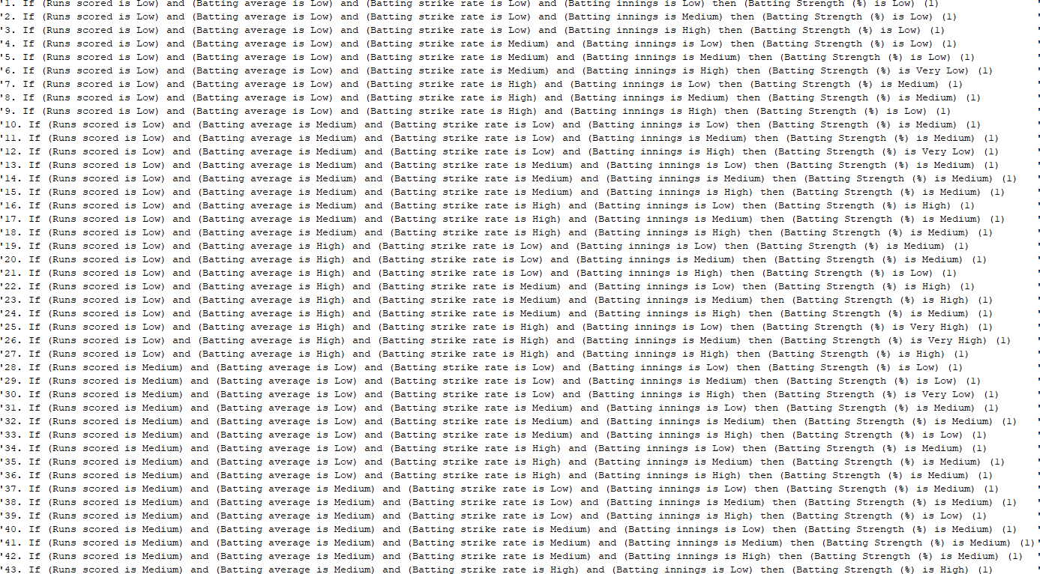

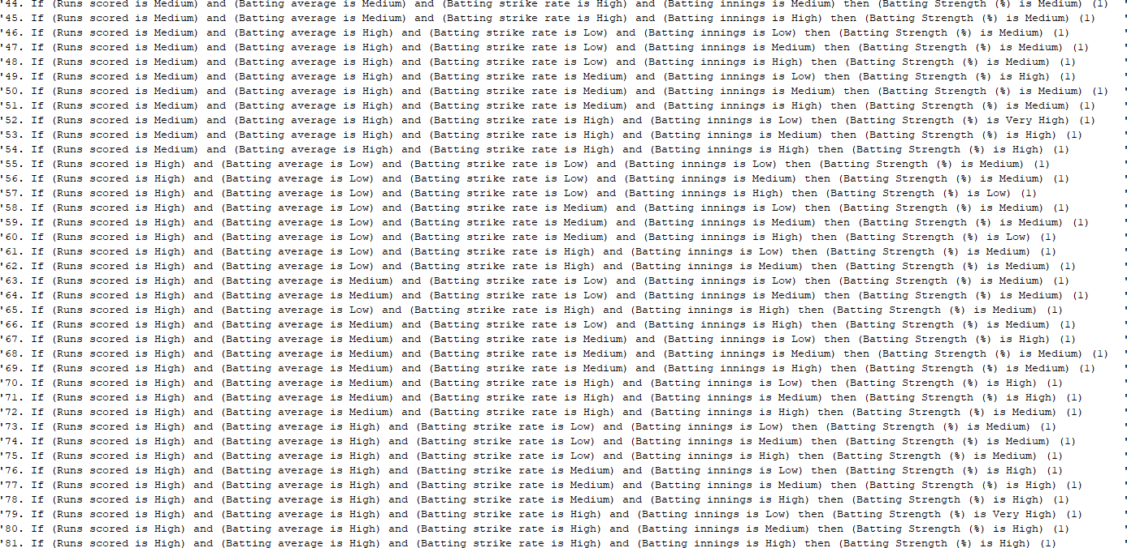

Bowling FIS:

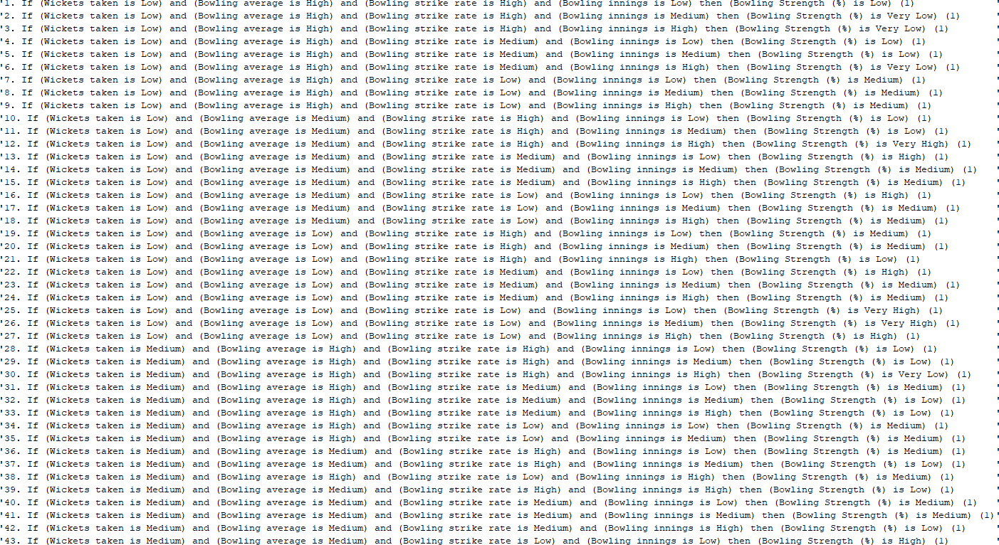

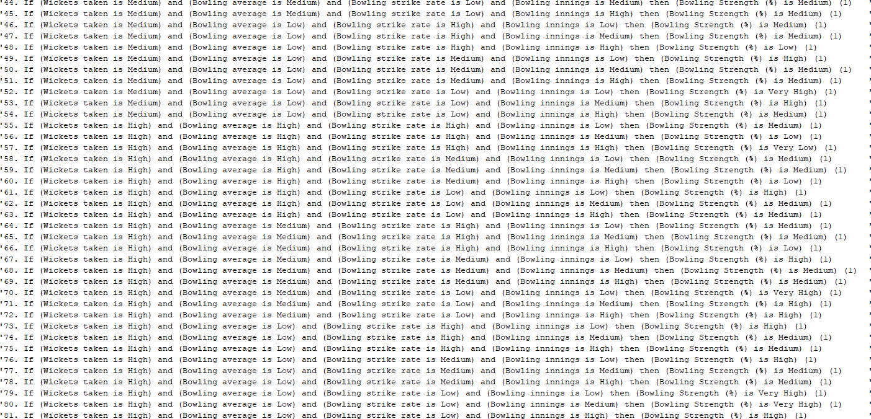

Removal of the intervals:

Batting FIS:

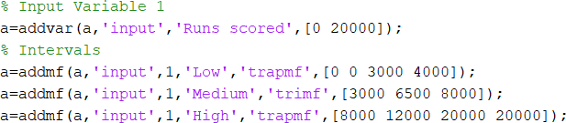

Bowling FIS:

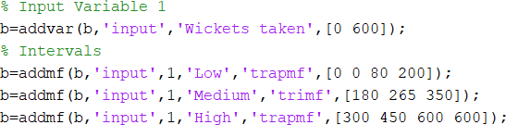

New fuzzy set distributions:

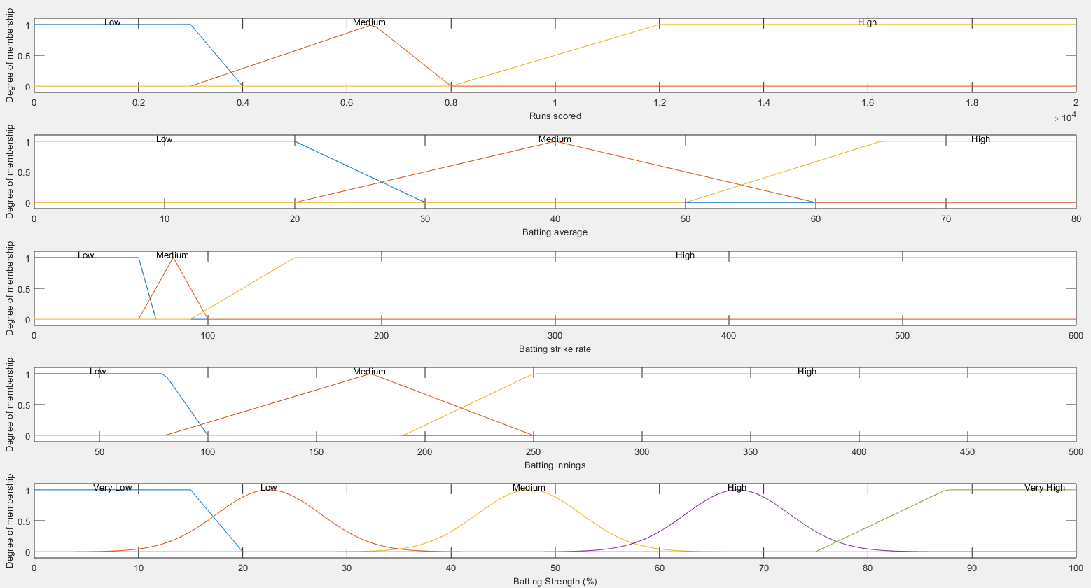

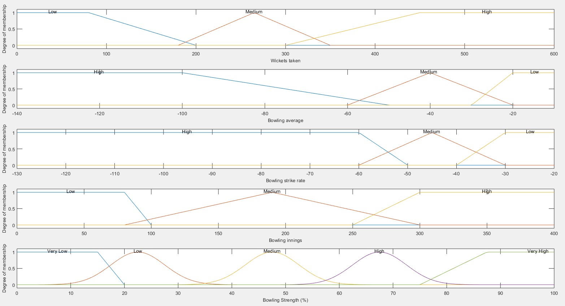

New Table of Expected Outcomes:

|  |  |  |  |
| --- | --- | --- | --- |
| **Test No.** | **Batting Strength** | **Bowling Strength** | **All-rounder Strength** |
| **1** | High | Low | Medium |
| **2** | High | Medium | Medium |
| **3** | Medium | Medium | Medium |
| **4** | Medium | Medium | Medium |
| **5** | High | High | High |
| **6** | Medium | Medium | Medium |
| **7** | High | Medium | Medium |
| **8** | Medium | Medium | Medium |
| **9** | Medium | Very Low | Low |
| **10** | High | Medium | Medium |
| **11** | Very Low | Very High | Medium |
| **12** | Very Low | Very High | Medium |
| **13** | Very Low | High | Medium |
| **14** | Low | Medium | Low |
| **15** | Medium | High | Medium |
| **16** | Low | High | Medium |
| **17** | Very Low | Medium | Low |
| **18** | Low | Very Low | Very Low |
| **19** | Low | Medium | Low |
| **20** | Very Low | Very High | Medium |
| **21** | High | Low | Medium |
| **22** | Low | Very Low | Very Low |
| **23** | Low | High | Medium |
| **24** | Low | High | Medium |
| **25** | High | Low | Medium |
| **26** | Medium | Medium | Medium |
| **27** | High | Low | Medium |
| **28** | Very Low | Medium | Low |
| **29** | Medium | Medium | Medium |
| **30** | Medium | Low | Low |

Defuzzification values for Test 2:

*Centroid vs Bisector:*

|  |  |  |  |  |  |  |
| --- | --- | --- | --- | --- | --- | --- |
| **Test No.** | **CENTROID** | | | **BISECTOR** | | |
| **Batting**  **Strength** | **Bowling**  **Strength** | **All-rounder**  **Strength** | **Batting**  **Strength** | **Bowling**  **Strength** | **All-rounder**  **Strength** |
| **1** | 47.5 | 53.11730689 | 47.52222816 | 47 | 48 | 48 |
| **2** | 47.5 | 67.5 | 47.5164241 | 47 | 67 | 48 |
| **3** | 52.48263177 | 67.5 | 48.06747948 | 50 | 67 | 48 |
| **4** | 67.5 | 69.53882671 | 67.48303429 | 67 | 68 | 67 |
| **5** | 67.5 | 83.85425955 | 67.48095561 | 67 | 86 | 67 |
| **6** | 47.5 | 67.5 | 47.5164241 | 47 | 67 | 48 |
| **7** | 47.5 | 67.5 | 47.5164241 | 47 | 67 | 48 |
| **8** | 61.54176712 | 67.5 | 66.41567468 | 64 | 67 | 67 |
| **9** | 57.74616249 | 22.50004903 | 36.04078694 | 58 | 23 | 40 |
| **10** | 47.5 | 67.5 | 47.5164241 | 47 | 67 | 48 |
| **11** | 22.50005102 | 58.68209759 | 39.7600269 | 23 | 61 | 47 |
| **12** | 15.31263752 | 57.17974923 | 33.64879482 | 14 | 56 | 26 |
| **13** | 14.94771691 | 50.85031303 | 22.75410206 | 14 | 49 | 23 |
| **14** | 22.50006238 | 22.50007039 | 22.50033467 | 23 | 23 | 23 |
| **15** | 54.31668193 | 89.74844792 | 67.49556889 | 52 | 90 | 67 |
| **16** | 22.50006676 | 85.97376361 | 47.50022068 | 23 | 88 | 48 |
| **17** | 22.50004903 | 22.50006374 | 22.50033467 | 23 | 23 | 23 |
| **18** | 24.04540322 | 22.50015783 | 22.50033708 | 23 | 23 | 23 |
| **19** | 30.63069265 | 41.14366667 | 22.95364725 | 28 | 44 | 23 |
| **20** | 22.50009574 | 84.09834613 | 47.50024072 | 23 | 86 | 48 |
| **21** | 47.5 | 31.45213282 | 23.43089638 | 47 | 28 | 23 |
| **22** | 23.15888531 | 22.50014954 | 22.50033489 | 23 | 23 | 23 |
| **23** | 29.19769152 | 48.78645011 | 22.62746208 | 27 | 48 | 23 |
| **24** | 47.5 | 47.5 | 47.5164241 | 48 | 47 | 48 |
| **25** | 47.5 | 47.5 | 47.5164241 | 48 | 47 | 48 |
| **26** | 37.23315142 | 67.5 | 47.40645395 | 40 | 67 | 47 |
| **27** | 47.5 | 29.19400718 | 22.62704488 | 47 | 25 | 23 |
| **28** | 32.49923865 | 52.40509789 | 24.76723473 | 28 | 50 | 23 |
| **29** | 63.27996826 | 67.5 | 67.16098479 | 65 | 67 | 67 |
| **30** | 47.5 | 47.5 | 47.5164241 | 47 | 47 | 48 |

*LOM vs SOM vs MOM:*

|  |  |  |  |  |  |  |  |  |  |
| --- | --- | --- | --- | --- | --- | --- | --- | --- | --- |
| **Test No.** | **LOM** | | | **SOM** | | | **MOM** | | |
| **Batting Strength** | **Bowling Strength** | **All- rounder**  **Strength** | **Batting Strength** | **Bowling Strength** | **All- rounder**  **Strength** | **Batting Strength** | **Bowling Strength** | **All- rounder**  **Strength** |
| **1** | 51 | 54 | 54 | 44 | 41 | 41 | 47.5 | 47.5 | 47.5 |
| **2** | 49 | 72 | 52 | 46 | 63 | 43 | 47.5 | 67.5 | 47.5 |
| **3** | 54 | 74 | 54 | 41 | 61 | 41 | 47.5 | 67.5 | 47.5 |
| **4** | 75 | 73 | 75 | 60 | 62 | 60 | 67.5 | 67.5 | 67.5 |
| **5** | 72 | 100 | 72 | 63 | 83 | 63 | 67.5 | 91.5 | 67.5 |
| **6** | 55 | 72 | 55 | 40 | 63 | 40 | 47.5 | 67.5 | 47.5 |
| **7** | 56 | 72 | 56 | 39 | 63 | 39 | 47.5 | 67.5 | 47.5 |
| **8** | 74 | 72 | 74 | 61 | 63 | 61 | 67.5 | 67.5 | 67.5 |
| **9** | 74 | 23 | 54 | 61 | 22 | 41 | 67.5 | 22.5 | 47.5 |
| **10** | 52 | 70 | 52 | 43 | 65 | 43 | 47.5 | 67.5 | 47.5 |
| **11** | 25 | 73 | 53 | 20 | 62 | 42 | 22.5 | 67.5 | 47.5 |
| **12** | 18 | 54 | 29 | 0 | 41 | 16 | 9 | 47.5 | 22.5 |
| **13** | 17 | 54 | 29 | 0 | 41 | 16 | 8.5 | 47.5 | 22.5 |
| **14** | 27 | 28 | 28 | 18 | 17 | 0 | 22.5 | 22.5 | 22.5 |
| **15** | 56 | 100 | 76 | 39 | 84 | 59 | 47.5 | 92 | 67.5 |
| **16** | 28 | 100 | 53 | 17 | 81 | 42 | 22.5 | 90.5 | 47.5 |
| **17** | 23 | 27 | 27 | 22 | 18 | 18 | 22.5 | 22.5 | 22.5 |
| **18** | 28 | 31 | 31 | 17 | 14 | 0 | 22.5 | 22.5 | 22.5 |
| **19** | 31 | 55 | 31 | 14 | 40 | 15 | 22.5 | 47.5 | 22.5 |
| **20** | 30 | 100 | 55 | 15 | 82 | 43 | 22.5 | 91 | 47.5 |
| **21** | 53 | 30 | 30 | 42 | 15 | 17 | 47.5 | 22.5 | 22.5 |
| **22** | 26 | 31 | 31 | 19 | 14 | 0 | 22.5 | 22.5 | 22.5 |
| **23** | 29 | 52 | 29 | 16 | 43 | 18 | 22.5 | 47.5 | 22.5 |
| **24** | 61 | 52 | 54 | 34 | 43 | 11 | 47.5 | 47.5 | 47.5 |
| **25** | 56 | 51 | 56 | 39 | 44 | 39 | 47.5 | 47.5 | 47.5 |
| **26** | 54 | 73 | 54 | 41 | 62 | 41 | 47.5 | 67.5 | 47.5 |
| **27** | 52 | 27 | 27 | 43 | 18 | 18 | 47.5 | 22.5 | 22.5 |
| **28** | 28 | 56 | 31 | 17 | 39 | 14 | 22.5 | 47.5 | 22.5 |
| **29** | 74 | 69 | 74 | 61 | 66 | 61 | 67.5 | 67.5 | 67.5 |
| **30** | 53 | 55 | 55 | 42 | 40 | 40 | 47.5 | 47.5 | 47.5 |

### Comparison of Expected Outcomes and Actual Outcomes:

*Centroid vs Bisector:*

|  |  |  |  |  |  |  |
| --- | --- | --- | --- | --- | --- | --- |
|  |  | **Centroid** |  |  | **Bisector** |  |
| **Test No.** | BATTING STRENGTH | BOWLING STRENGTH | ALL-  ROUNDER  STRENGTH | BATTING STRENGTH | BOWLING STRENGTH | ALL-  ROUNDER  STRENGTH |
| 1 | FALSE | FALSE | TRUE | FALSE | FALSE | TRUE |
| 2 | FALSE | FALSE | TRUE | FALSE | FALSE | TRUE |
| 3 | TRUE | FALSE | TRUE | TRUE | FALSE | TRUE |
| 4 | FALSE | FALSE | FALSE | FALSE | FALSE | FALSE |
| 5 | TRUE | FALSE | TRUE | TRUE | FALSE | TRUE |
| 6 | TRUE | FALSE | TRUE | TRUE | FALSE | TRUE |
| 7 | FALSE | FALSE | TRUE | FALSE | FALSE | TRUE |
| 8 | FALSE | FALSE | FALSE | FALSE | FALSE | FALSE |
| 9 | TRUE | FALSE | FALSE | TRUE | FALSE | FALSE |
| 10 | FALSE | FALSE | TRUE | FALSE | FALSE | TRUE |
| 11 | FALSE | FALSE | TRUE | FALSE | FALSE | TRUE |
| 12 | TRUE | FALSE | FALSE | TRUE | FALSE | FALSE |
| 13 | TRUE | FALSE | FALSE | TRUE | FALSE | FALSE |
| 14 | TRUE | FALSE | TRUE | TRUE | FALSE | TRUE |
| 15 | TRUE | FALSE | FALSE | TRUE | FALSE | FALSE |
| 16 | TRUE | FALSE | TRUE | TRUE | FALSE | TRUE |
| 17 | FALSE | FALSE | TRUE | FALSE | FALSE | TRUE |
| 18 | TRUE | FALSE | FALSE | TRUE | FALSE | FALSE |
| 19 | TRUE | TRUE | TRUE | TRUE | TRUE | TRUE |
| 20 | FALSE | TRUE | TRUE | FALSE | TRUE | TRUE |
| 21 | FALSE | TRUE | FALSE | FALSE | TRUE | FALSE |
| 22 | TRUE | FALSE | FALSE | TRUE | FALSE | FALSE |
| 23 | TRUE | FALSE | FALSE | TRUE | FALSE | FALSE |
| 24 | FALSE | FALSE | TRUE | FALSE | FALSE | TRUE |
| 25 | FALSE | FALSE | TRUE | FALSE | FALSE | TRUE |
| 26 | TRUE | FALSE | TRUE | TRUE | FALSE | TRUE |
| 27 | FALSE | TRUE | FALSE | FALSE | TRUE | FALSE |
| 28 | FALSE | TRUE | TRUE | FALSE | TRUE | TRUE |
| 29 | FALSE | FALSE | FALSE | FALSE | FALSE | FALSE |
| 30 | TRUE | FALSE | FALSE | TRUE | FALSE | FALSE |

#### Evaluation:

* + Centroid:
    - Batting Strength: **15/30** correct test cases
    - Bowling Strength: **5/30** correct test cases
    - All-rounder Strength: **17/30** correct test cases
  + Bisector:
    - Batting Strength: **15/30** correct test cases
    - Bowling Strength: **15/30** correct test cases
    - All-rounder Strength: **17/30** correct test cases

*LOM vs SOM vs MOM:*

|  |  |  |  |  |  |  |  |  |  |
| --- | --- | --- | --- | --- | --- | --- | --- | --- | --- |
|  |  | **LOM** |  |  | **SOM** |  |  | **MOM** |  |
| **Test No.** | BATTING STRENGTH | BOWLING STRENGTH | ALL-  ROUNDER STRENGTH | BATTING STRENGTH | BOWLING STRENGTH | ALL-  ROUNDER STRENGTH | BATTING STRENGTH | BOWLING STRENGTH | ALL-  ROUNDER STRENGTH |
| 1 | FALSE | FALSE | TRUE | FALSE | FALSE | TRUE | FALSE | FALSE | TRUE |
| 2 | FALSE | FALSE | TRUE | FALSE | FALSE | TRUE | FALSE | FALSE | TRUE |
| 3 | TRUE | FALSE | TRUE | TRUE | FALSE | TRUE | TRUE | FALSE | TRUE |
| 4 | FALSE | FALSE | FALSE | FALSE | FALSE | FALSE | FALSE | FALSE | FALSE |
| 5 | TRUE | FALSE | TRUE | TRUE | FALSE | TRUE | TRUE | FALSE | TRUE |
| 6 | TRUE | FALSE | TRUE | TRUE | FALSE | TRUE | TRUE | FALSE | TRUE |
| 7 | FALSE | FALSE | TRUE | FALSE | FALSE | TRUE | FALSE | FALSE | TRUE |
| 8 | FALSE | FALSE | FALSE | FALSE | FALSE | FALSE | FALSE | FALSE | FALSE |
| 9 | FALSE | FALSE | FALSE | FALSE | FALSE | FALSE | FALSE | FALSE | FALSE |
| 10 | FALSE | FALSE | TRUE | FALSE | FALSE | TRUE | FALSE | FALSE | TRUE |
| 11 | FALSE | FALSE | TRUE | FALSE | FALSE | TRUE | FALSE | FALSE | TRUE |
| 12 | TRUE | FALSE | FALSE | TRUE | FALSE | FALSE | TRUE | FALSE | FALSE |
| 13 | TRUE | FALSE | FALSE | TRUE | FALSE | FALSE | TRUE | FALSE | FALSE |
| 14 | TRUE | FALSE | TRUE | FALSE | FALSE | FALSE | TRUE | FALSE | TRUE |
| 15 | TRUE | FALSE | FALSE | TRUE | FALSE | FALSE | TRUE | FALSE | FALSE |
| 16 | TRUE | FALSE | TRUE | FALSE | FALSE | TRUE | TRUE | FALSE | TRUE |
| 17 | FALSE | FALSE | TRUE | FALSE | FALSE | FALSE | FALSE | FALSE | TRUE |
| 18 | TRUE | FALSE | FALSE | FALSE | TRUE | TRUE | TRUE | FALSE | FALSE |
| 19 | TRUE | TRUE | TRUE | FALSE | TRUE | FALSE | TRUE | TRUE | TRUE |
| 20 | FALSE | TRUE | TRUE | TRUE | TRUE | TRUE | FALSE | TRUE | TRUE |
| 21 | FALSE | TRUE | FALSE | FALSE | FALSE | FALSE | FALSE | TRUE | FALSE |
| 22 | TRUE | FALSE | FALSE | TRUE | TRUE | TRUE | TRUE | FALSE | FALSE |
| 23 | TRUE | FALSE | FALSE | FALSE | FALSE | FALSE | TRUE | FALSE | FALSE |
| 24 | FALSE | FALSE | TRUE | TRUE | FALSE | FALSE | FALSE | FALSE | TRUE |
| 25 | FALSE | FALSE | TRUE | FALSE | FALSE | TRUE | FALSE | FALSE | TRUE |
| 26 | TRUE | FALSE | TRUE | TRUE | FALSE | TRUE | TRUE | FALSE | TRUE |
| 27 | FALSE | TRUE | FALSE | FALSE | FALSE | FALSE | FALSE | TRUE | FALSE |
| 28 | FALSE | TRUE | TRUE | TRUE | TRUE | FALSE | FALSE | TRUE | TRUE |
| 29 | FALSE | FALSE | FALSE | FALSE | FALSE | FALSE | FALSE | FALSE | FALSE |
| 30 | TRUE | FALSE | FALSE | TRUE | FALSE | FALSE | TRUE | FALSE | FALSE |

#### Evaluation:

* + LOM:
    - Batting Strength: **14/30** correct test cases
    - Bowling Strength: **5/30** correct test cases
    - All-rounder Strength: **17/30** correct test cases
  + SOM:
    - Batting Strength: **12/30** correct test cases
    - Bowling Strength: **5/30** correct test cases
    - All-rounder Strength: **14/30** correct test cases
  + MOM:
    - Batting Strength: **14/30** correct test cases
    - Bowling Strength: **5/30** correct test cases
    - All-rounder Strength: **17/30** correct test cases

# Test 3:

### Defuzzification Values:

*Centroid vs Bisector vs LOM:*

|  |  |  |  |  |  |  |  |  |  |
| --- | --- | --- | --- | --- | --- | --- | --- | --- | --- |
| **Test No.** | **CENTROID** | | | **BISECTOR** | | | **LOM** | | |
| **Batting Strength** | **Bowling Strength** | **All-rounder Strength** | **Batting Strength** | **Bowling Strength** | **All- rounder**  **Strength** | **Batting Strength** | **Bowling Strength** | **All- rounder**  **Strength** |
| **1** | 67.5 | 18.07145526 | 37.28945654 | 67 | 19 | 45 | 71 | 29 | 54 |
| **2** | 67.5 | 47.5 | 47.5164241 | 67 | 48 | 48 | 69 | 52 | 52 |
| **3** | 52.48263177 | 47.5 | 47.52047301 | 50 | 47 | 48 | 54 | 54 | 54 |
| **4** | 47.5 | 49.75009121 | 47.5168091 | 47 | 48 | 48 | 55 | 53 | 55 |
| **5** | 67.5 | 61.27713104 | 66.21144004 | 67 | 64 | 67 | 72 | 72 | 72 |
| **6** | 38.48365371 | 47.5 | 46.51617159 | 42 | 47 | 47 | 55 | 52 | 55 |
| **7** | 67.5 | 47.5 | 47.5164241 | 67 | 47 | 48 | 76 | 52 | 56 |
| **8** | 47.5 | 47.5 | 47.5164241 | 48 | 47 | 48 | 54 | 52 | 54 |
| **9** | 47.5 | 8.555555556 | 22.52255121 | 47 | 8 | 23 | 54 | 15 | 29 |
| **10** | 67.5 | 47.5 | 47.5164241 | 67 | 47 | 48 | 72 | 50 | 52 |
| **11** | 8.701731025 | 80.83454688 | 47.49999998 | 9 | 83 | 47 | 15 | 100 | 48 |
| **12** | 9.358615743 | 78.85688836 | 47.49999971 | 9 | 79 | 47 | 18 | 74 | 54 |
| **13** | 9.114583333 | 70.6922018 | 47.49844607 | 9 | 69 | 47 | 17 | 74 | 54 |
| **14** | 22.50006238 | 47.08670499 | 22.51638253 | 23 | 47 | 23 | 27 | 53 | 28 |
| **15** | 47.5 | 67.5 | 47.5164241 | 48 | 67 | 48 | 56 | 71 | 56 |
| **16** | 22.50006676 | 64.06710533 | 47.23113046 | 23 | 66 | 47 | 28 | 73 | 53 |
| **17** | 8.555555556 | 47.5 | 22.52255121 | 8 | 47 | 23 | 15 | 52 | 27 |
| **18** | 23.28312225 | 24.53841866 | 22.50066633 | 23 | 16 | 12 | 28 | 19 | 28 |
| **19** | 23.79260908 | 39.53854719 | 22.50218599 | 19 | 43 | 22 | 19 | 55 | 30 |
| **20** | 9.322580645 | 84.09834613 | 47.5 | 9 | 86 | 48 | 18 | 100 | 52 |
| **21** | 67.5 | 38.71465241 | 47.44083493 | 67 | 28 | 47 | 73 | 30 | 55 |
| **22** | 23.15888531 | 20.6706931 | 22.50009513 | 23 | 14 | 10 | 26 | 19 | 26 |
| **23** | 23.17556325 | 67.92013608 | 47.48384248 | 20 | 68 | 47 | 18 | 72 | 52 |
| **24** | 57.49999999 | 67.5 | 57.49999995 | 57 | 67 | 54 | 81 | 72 | 73 |
| **25** | 67.5 | 22.50005491 | 47.47759766 | 67 | 23 | 47 | 76 | 26 | 56 |
| **26** | 36.51725511 | 47.5 | 42.58270506 | 40 | 47 | 47 | 54 | 53 | 54 |
| **27** | 67.5 | 29.19400718 | 47.46368885 | 67 | 25 | 47 | 72 | 27 | 52 |
| **28** | 14.17161484 | 50.35733832 | 22.6803907 | 13 | 49 | 23 | 17 | 56 | 31 |
| **29** | 47.5 | 47.5 | 47.5164241 | 48 | 47 | 48 | 54 | 49 | 54 |
| **30** | 47.5 | 32.47405672 | 24.72045542 | 47 | 29 | 23 | 53 | 30 | 30 |

### Comparison of Expected Outcomes and Actual Outcomes:

*Centroid vs Bisector vs LOM:*

|  |  |  |  |  |  |  |  |  |  |
| --- | --- | --- | --- | --- | --- | --- | --- | --- | --- |
|  |  | **Centroid** |  |  | **Bisector** |  |  | **LOM** |  |
| **Test No.** | BATTING STRENGTH | BOWLING STRENGTH | ALL-  ROUNDER STRENGTH | BATTING STRENGTH | BOWLING STRENGTH | ALL-  ROUNDER STRENGTH | BATTING STRENGTH | BOWLING STRENGTH | ALL-  ROUNDER STRENGTH |
| 1 | TRUE | FALSE | TRUE | TRUE | TRUE | TRUE | TRUE | TRUE | TRUE |
| 2 | TRUE | TRUE | TRUE | TRUE | TRUE | TRUE | TRUE | TRUE | TRUE |
| 3 | TRUE | TRUE | TRUE | TRUE | TRUE | TRUE | TRUE | TRUE | TRUE |
| 4 | TRUE | TRUE | TRUE | TRUE | TRUE | TRUE | TRUE | TRUE | TRUE |
| 5 | TRUE | TRUE | TRUE | TRUE | TRUE | TRUE | TRUE | TRUE | TRUE |
| 6 | TRUE | TRUE | TRUE | TRUE | TRUE | TRUE | TRUE | TRUE | TRUE |
| 7 | TRUE | TRUE | TRUE | TRUE | TRUE | TRUE | TRUE | TRUE | TRUE |
| 8 | TRUE | TRUE | TRUE | TRUE | TRUE | TRUE | TRUE | TRUE | TRUE |
| 9 | TRUE | TRUE | TRUE | TRUE | TRUE | TRUE | TRUE | TRUE | TRUE |
| 10 | TRUE | TRUE | TRUE | TRUE | TRUE | TRUE | TRUE | TRUE | TRUE |
| 11 | TRUE | TRUE | TRUE | TRUE | TRUE | TRUE | TRUE | TRUE | TRUE |
| 12 | TRUE | FALSE | TRUE | TRUE | TRUE | TRUE | TRUE | FALSE | TRUE |
| 13 | TRUE | TRUE | TRUE | TRUE | TRUE | TRUE | TRUE | TRUE | TRUE |
| 14 | TRUE | TRUE | TRUE | TRUE | TRUE | TRUE | TRUE | TRUE | TRUE |
| 15 | TRUE | TRUE | TRUE | TRUE | TRUE | TRUE | TRUE | TRUE | TRUE |
| 16 | TRUE | TRUE | TRUE | TRUE | TRUE | TRUE | TRUE | TRUE | TRUE |
| 17 | TRUE | TRUE | TRUE | TRUE | TRUE | TRUE | TRUE | TRUE | TRUE |
| 18 | TRUE | FALSE | FALSE | TRUE | TRUE | TRUE | TRUE | FALSE | FALSE |
| 19 | TRUE | TRUE | TRUE | TRUE | TRUE | TRUE | TRUE | TRUE | TRUE |
| 20 | TRUE | TRUE | TRUE | TRUE | TRUE | TRUE | TRUE | TRUE | TRUE |
| 21 | TRUE | FALSE | TRUE | TRUE | TRUE | TRUE | TRUE | TRUE | TRUE |
| 22 | TRUE | FALSE | FALSE | TRUE | TRUE | TRUE | TRUE | FALSE | FALSE |
| 23 | TRUE | TRUE | TRUE | TRUE | TRUE | TRUE | FALSE | TRUE | TRUE |
| 24 | FALSE | TRUE | TRUE | FALSE | TRUE | TRUE | FALSE | TRUE | FALSE |
| 25 | TRUE | TRUE | TRUE | TRUE | TRUE | TRUE | TRUE | TRUE | TRUE |
| 26 | TRUE | TRUE | TRUE | TRUE | TRUE | TRUE | TRUE | TRUE | TRUE |
| 27 | TRUE | TRUE | TRUE | TRUE | TRUE | TRUE | TRUE | TRUE | TRUE |
| 28 | TRUE | TRUE | TRUE | TRUE | TRUE | TRUE | TRUE | TRUE | TRUE |
| 29 | TRUE | TRUE | TRUE | TRUE | TRUE | TRUE | TRUE | TRUE | TRUE |
| 30 | TRUE | TRUE | TRUE | TRUE | TRUE | TRUE | TRUE | TRUE | TRUE |

#### Evaluation:

* + Centroid:
    - Batting Strength: **29/30** correct test cases
    - Bowling Strength: **25/30** correct test cases
    - All-rounder Strength: **28/30** correct test cases
  + Bisector:
    - Batting Strength: **29/30** correct test cases
    - Bowling Strength: **30/30** correct test cases
    - All-rounder Strength: **30/30** correct test cases
  + LOM:
    - Batting Strength: **28/30** correct test cases
    - Bowling Strength: **27/30** correct test cases
    - All-rounder Strength: **27/30** correct test cases

*New Bisector Values:*

|  |  |  |  |
| --- | --- | --- | --- |
| **Test No.** | **Batting Strength** | **Bowling Strength** | **All-rounder Strength** |
| **1** | 67 | 23 | 47 |
| **2** | 67 | 48 | 48 |
| **3** | 50 | 47 | 47 |
| **4** | 47 | 48 | 47 |
| **5** | 67 | 64 | 67 |
| **6** | 43 | 47 | 47 |
| **7** | 61 | 47 | 47 |
| **8** | 48 | 47 | 47 |
| **9** | 47 | 8 | 28 |
| **10** | 67 | 47 | 47 |
| **11** | 9 | 83 | 47 |
| **12** | 9 | 79 | 47 |
| **13** | 9 | 69 | 47 |
| **14** | 28 | 47 | 28 |
| **15** | 48 | 67 | 48 |
| **16** | 28 | 66 | 47 |
| **17** | 8 | 47 | 28 |
| **18** | 28 | 16 | 10 |
| **19** | 19 | 44 | 27 |
| **20** | 9 | 86 | 48 |
| **21** | 67 | 33 | 47 |
| **22** | 28 | 14 | 9 |
| **23** | 22 | 68 | 47 |
| **24** | 33 | 67 | 47 |
| **25** | 59 | 28 | 44 |
| **26** | 41 | 47 | 47 |
| **27** | 67 | 30 | 47 |
| **28** | 15 | 49 | 28 |
| **29** | 48 | 47 | 47 |
| **30** | 47 | 34 | 28 |

# Final System design in MATLAB:

### Variable declarations:

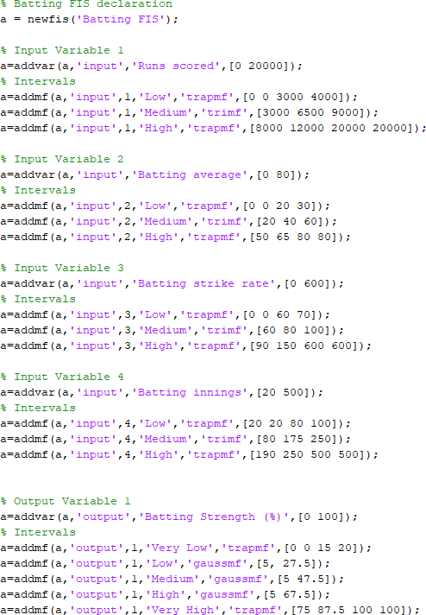

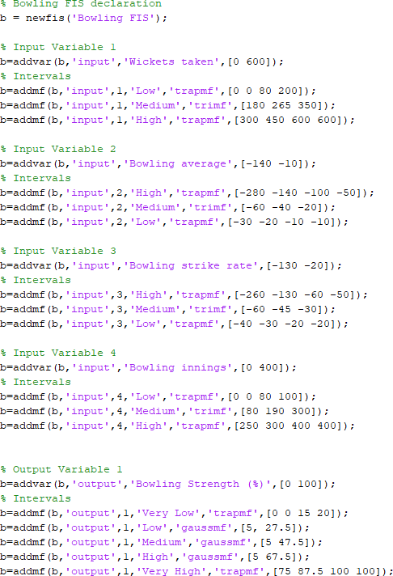

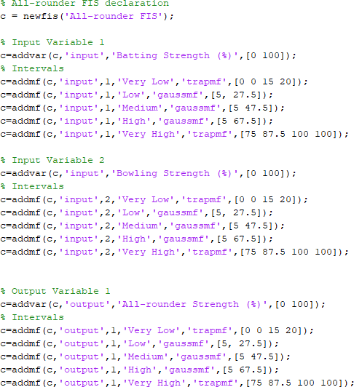

Rule bases:

#### Batting FIS:

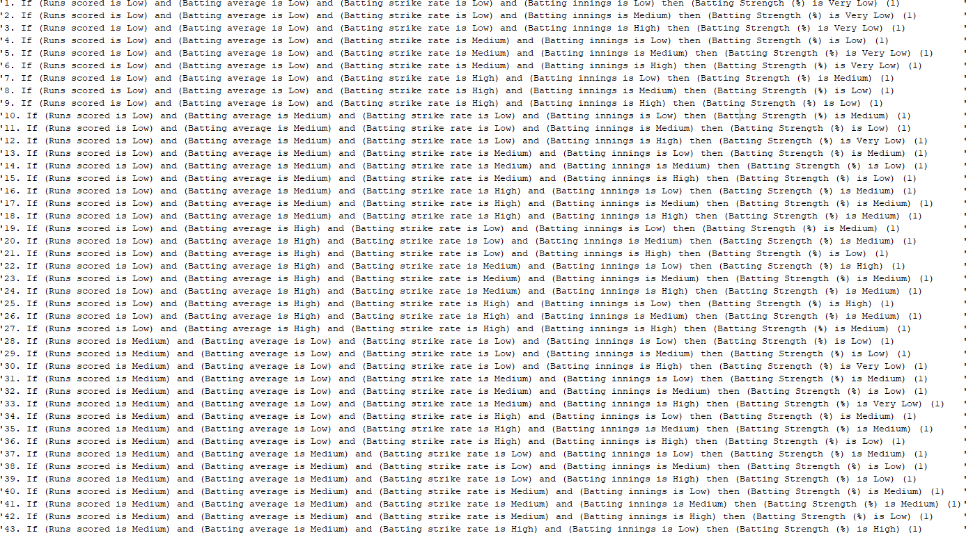

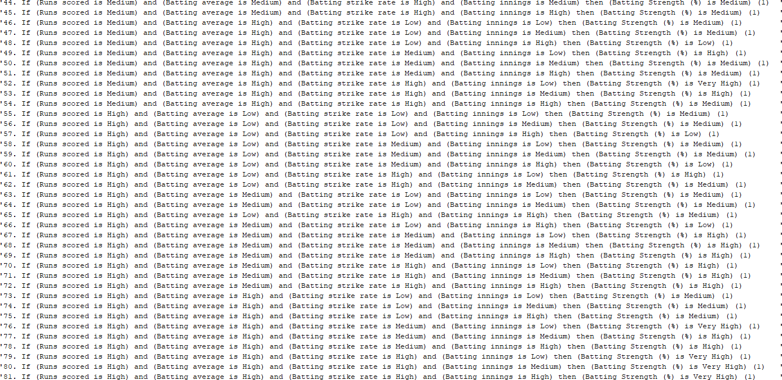

Bowling FIS:

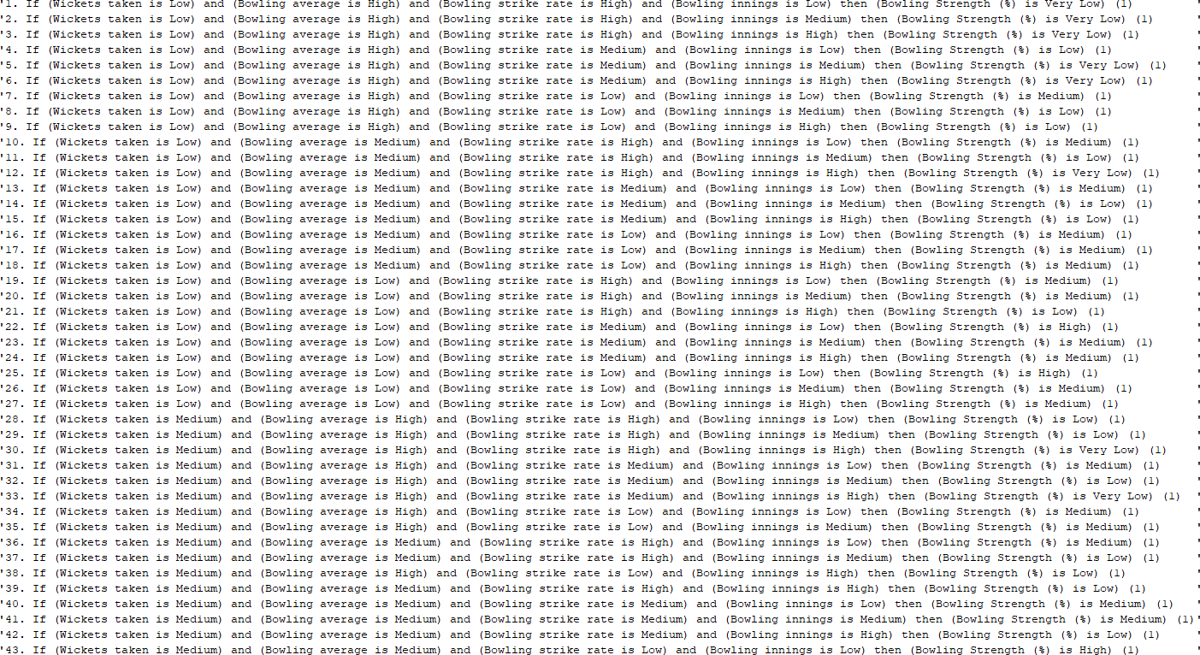

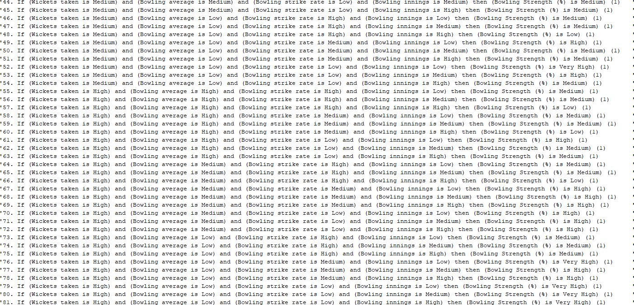

All-rounder FIS:



Fuzzy Sets:

